OSKAR memo XX:

The application of analytical time smearing.

# Introduction

OSKAR implements analytical time smearing of visibility samples for each correlator dump based on the equation:

[TODO]

This memo investigates the analytical time smearing performance of OSKAR by comparing simulations using analytical time smearing to those using an average of a large number of sub-intervals.

# Simulation configuration

Simulations were performed of a single snapshot observation with the July 2015 SKA1-Mid configuration of 197 antennas. Station beam effects were disabled and the simulation was performed in single polarisation Stokes-I mode using OSKAR 2.6.1.

The length of the snapshot observation was varied to take the following values 0.05s, 0.1s, 0.5s, and 1.0s and the snapshot was either simulated as a single correlator dump or a series of shorter correlator dumps which have been averaged. The number of time steps within a correlator dump was varied to be 1, 2, 10, or 1000 steps within the dump time. All simulations were performed in double precision, imaging was performed with the default CASA precision for CASA 4.4.0-REL (r33623) running on OS X 10.11.1.

* Telescope model:
  + ska1_meerkat_mid_combined_july_2015.tm (197 antennas, ~157km maximum baseline)
  + Longitude: 21.442909 degrees
  + Latitude: -30.739475 degrees
  + Isotropic beam model
* Observation settings:
  + Frequency: 700.0 MHz
  + Channel bandwidth: 0.0 MHz
  + RA: -90.3545848760 degrees
  + Dec: -8.5711239906 degrees
  + Start time: 57086.113194 MJD UTC
  + Observation length: 0.05s, 0.1s, 0.5s, 1.0s
  + Snapshots per observation: 1, 2, 10, or 1000.
* Sky model:
  + Single 1Jy source, +0.9 degrees in declination from the observation phase centre (i.e. Dec: -7.6711239906 degrees)

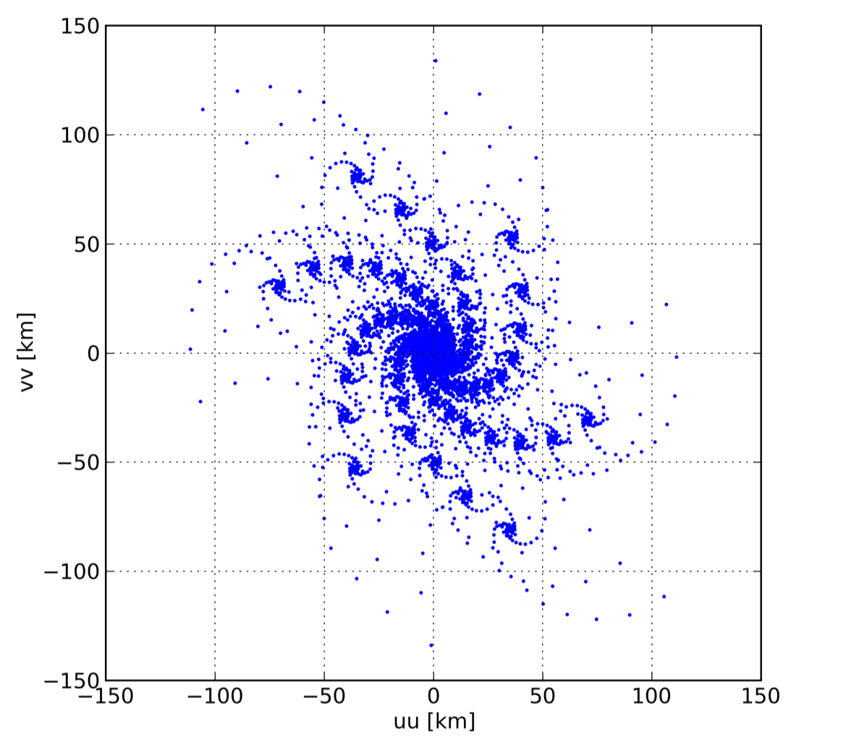

Figure : Snapshot uu-vv baseline distribution

## Measurement set averaging

Comparisons are made between a single correlator dump and (with and without analytical time smearing correction) and the same correlator dump formed by averaging a number of sub intervals. The sub-intervals were also simulated with and without analytical time smearing.

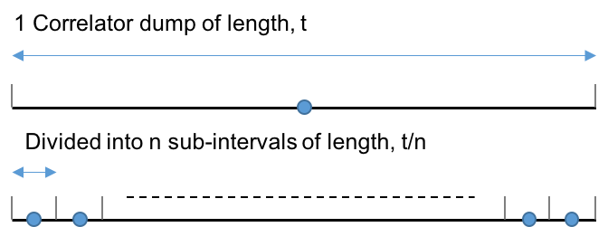

Figure : Averaging sub-intervals to form a correlator dump

# Results

Dirty images with a field-of-view of 0.02 degrees and 512 by 512 pixels where made centred on the source using CASA. Standard 2D imaging (no w-projection) was used. Figure 2 shows the dirty image produced from the simulation for a single snapshot. All subsequent results will show differences between images with using different methods to obtain time smearing.

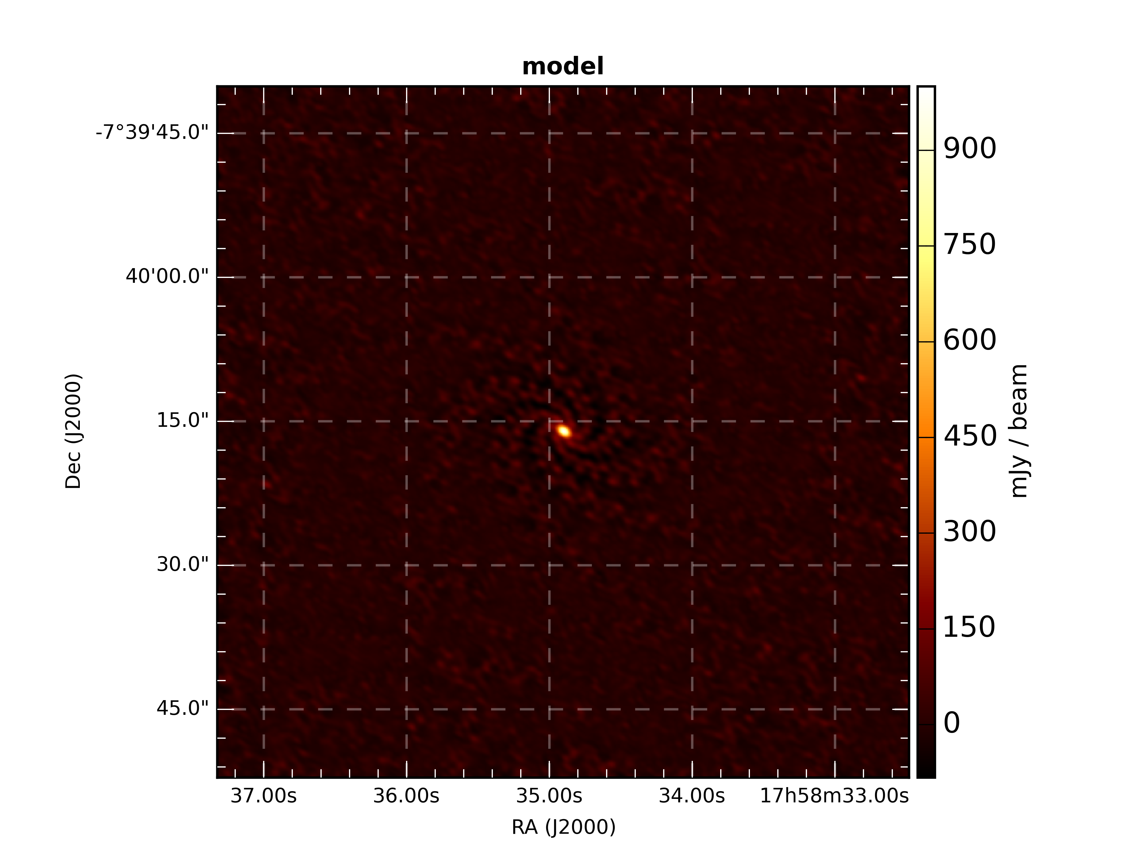

Figure : Dirty image centred on the source, 0.9 degrees from the observation phase centre.

## Simulation 1: 0.05 second correlator dump time

### 1 snapshot

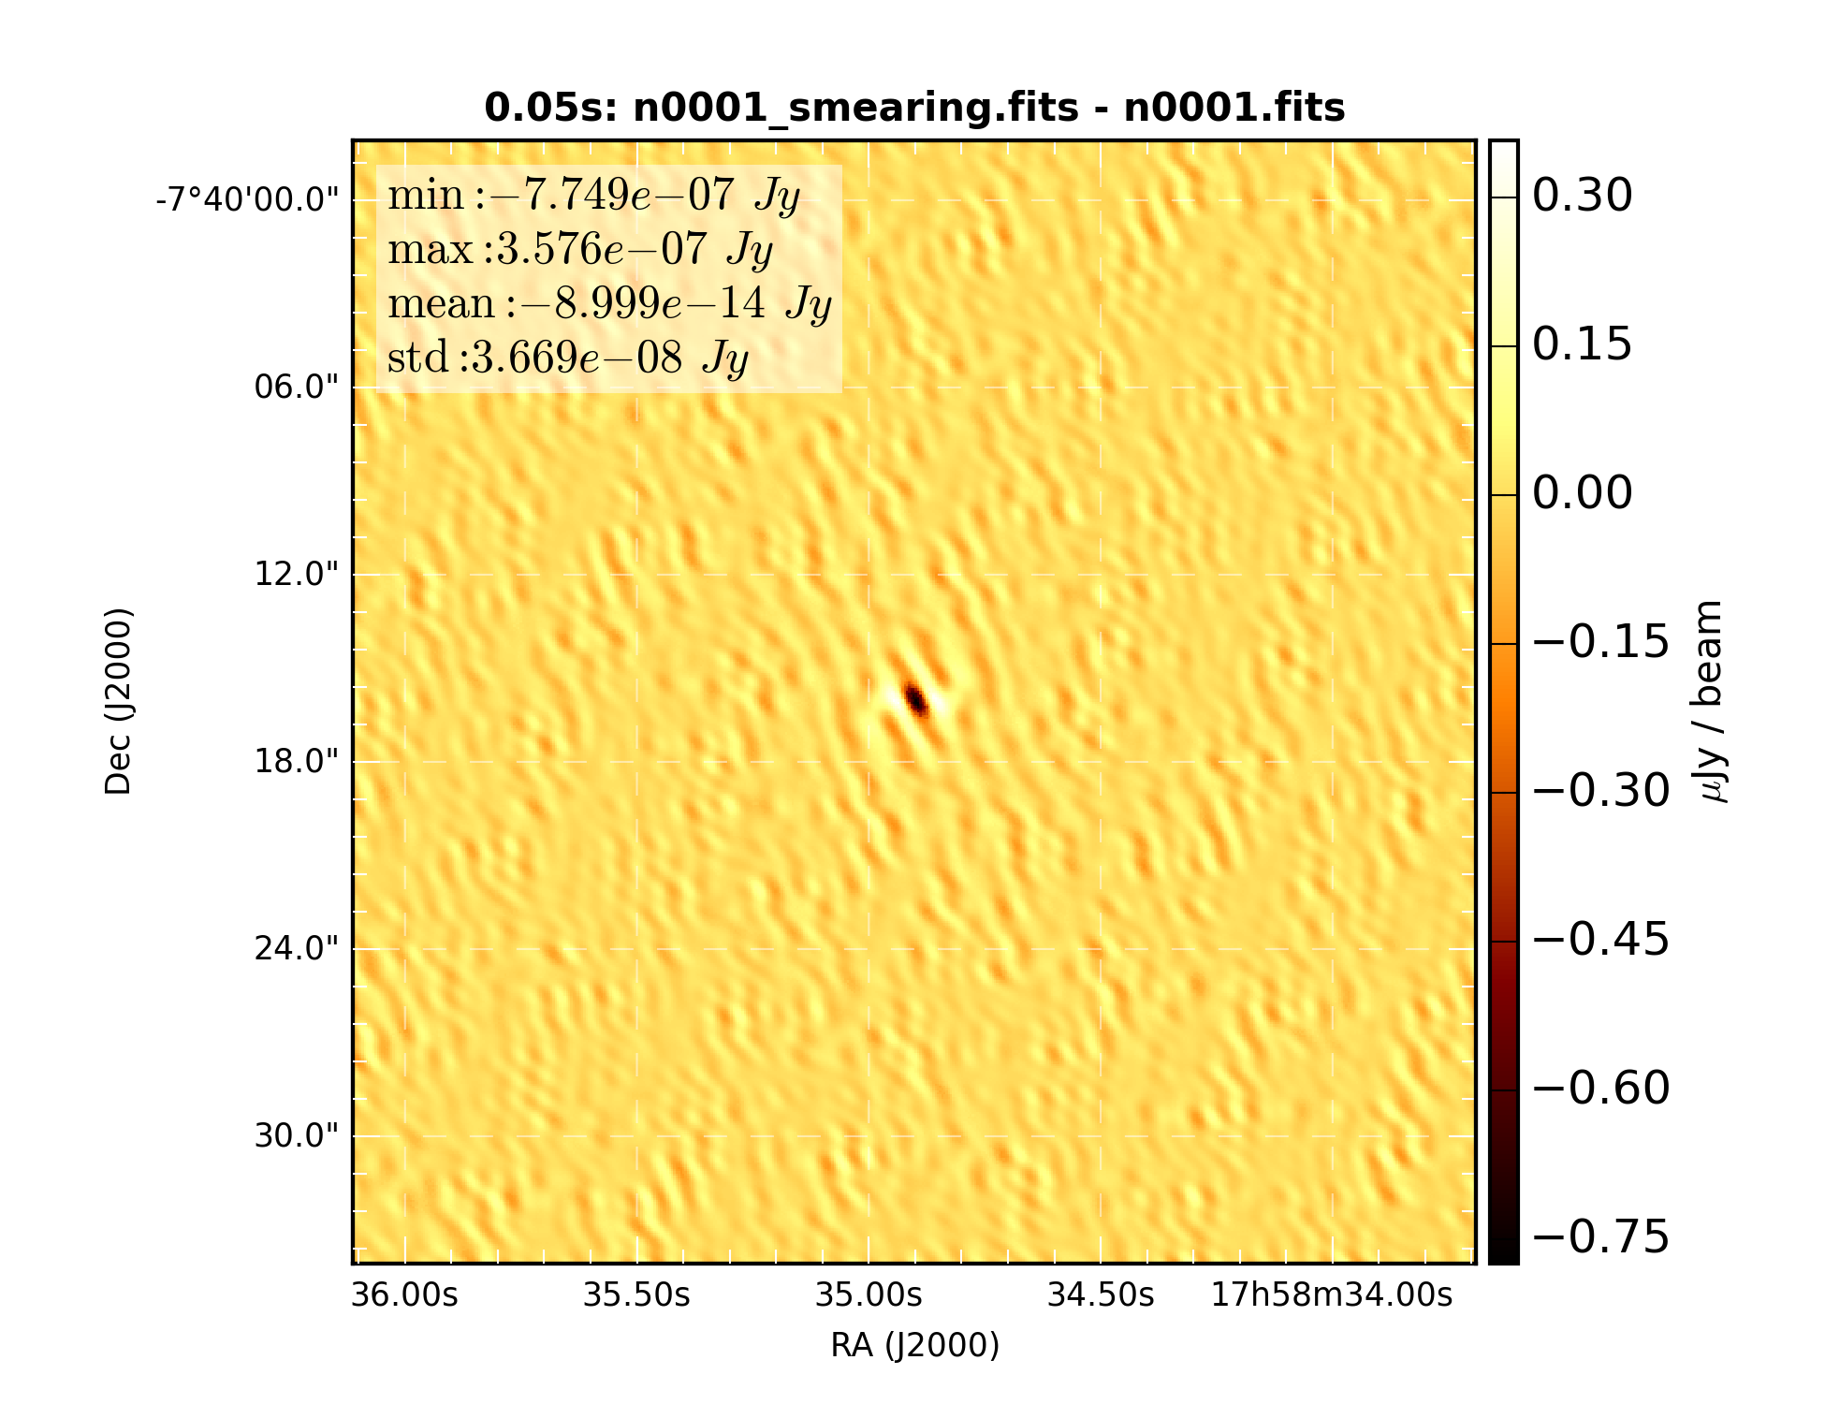

Figure 4: Difference of snapshot dirty images with and without time smearing correction

### Average of 2 snapshots

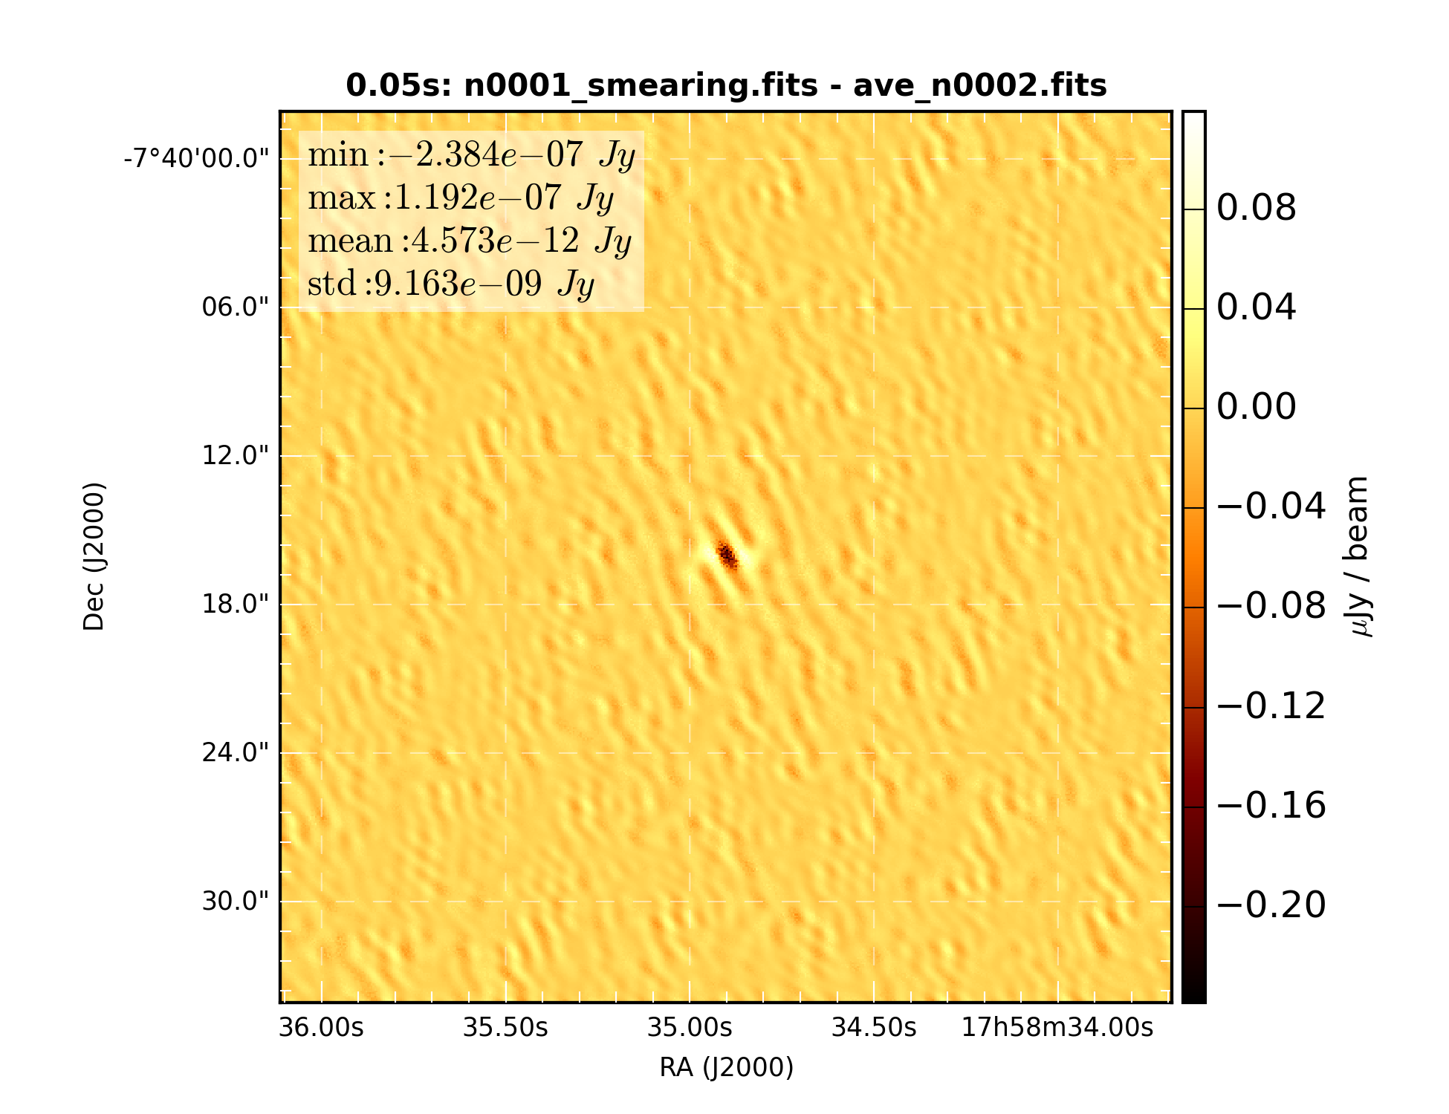

Figure 5: Difference of snapshot dirty image with average of 2 sub-samples.

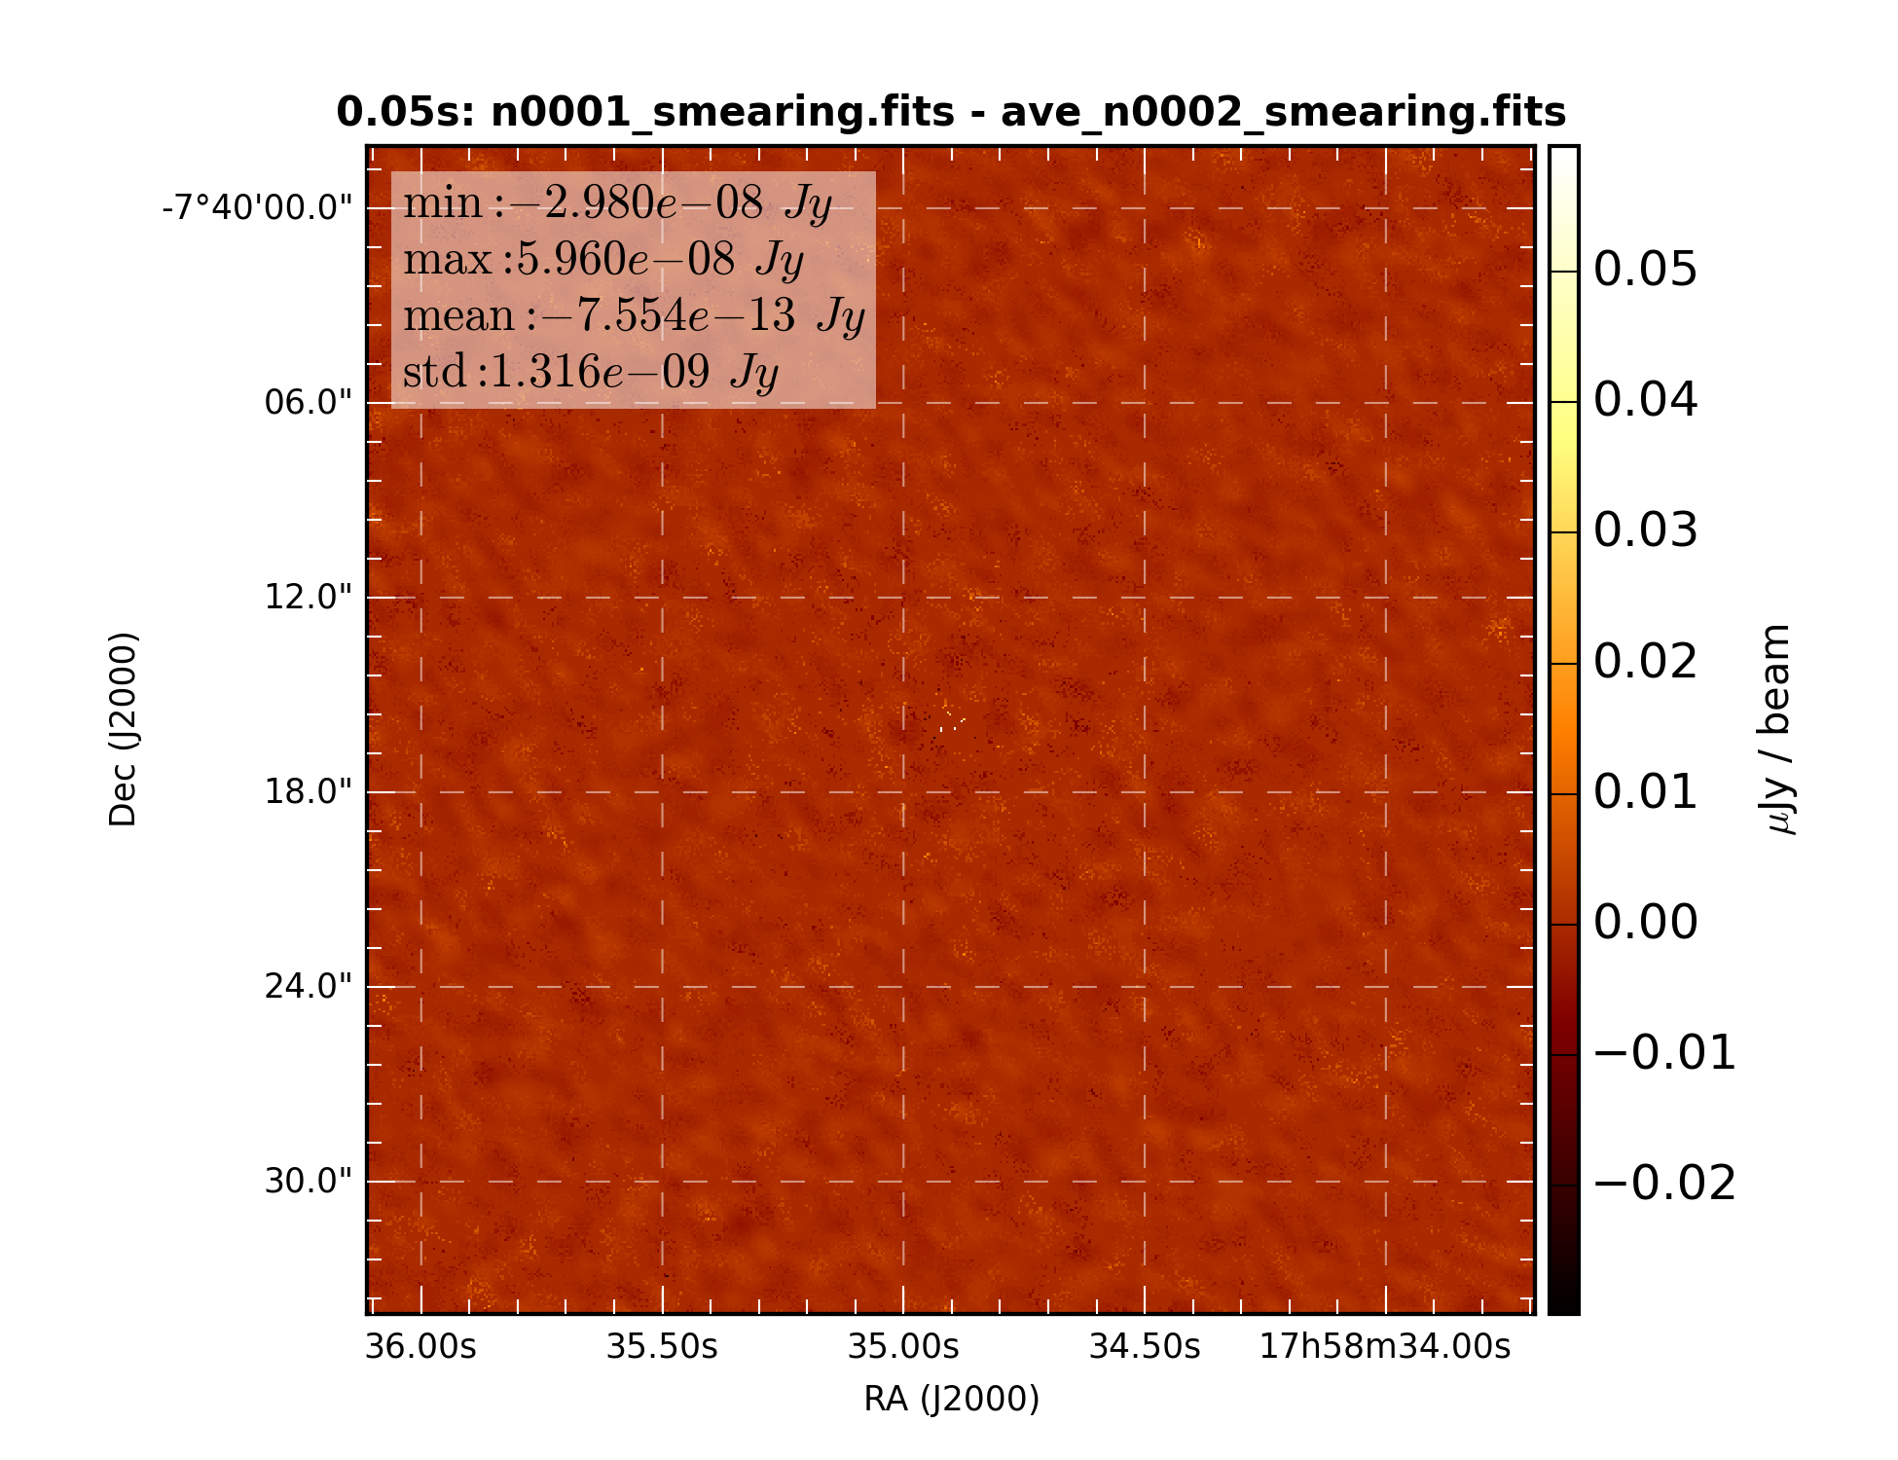

Figure 6: Difference of snapshot dirty image with average of 2 time smearing corrected sub-samples.

### Average of 10 snapshots

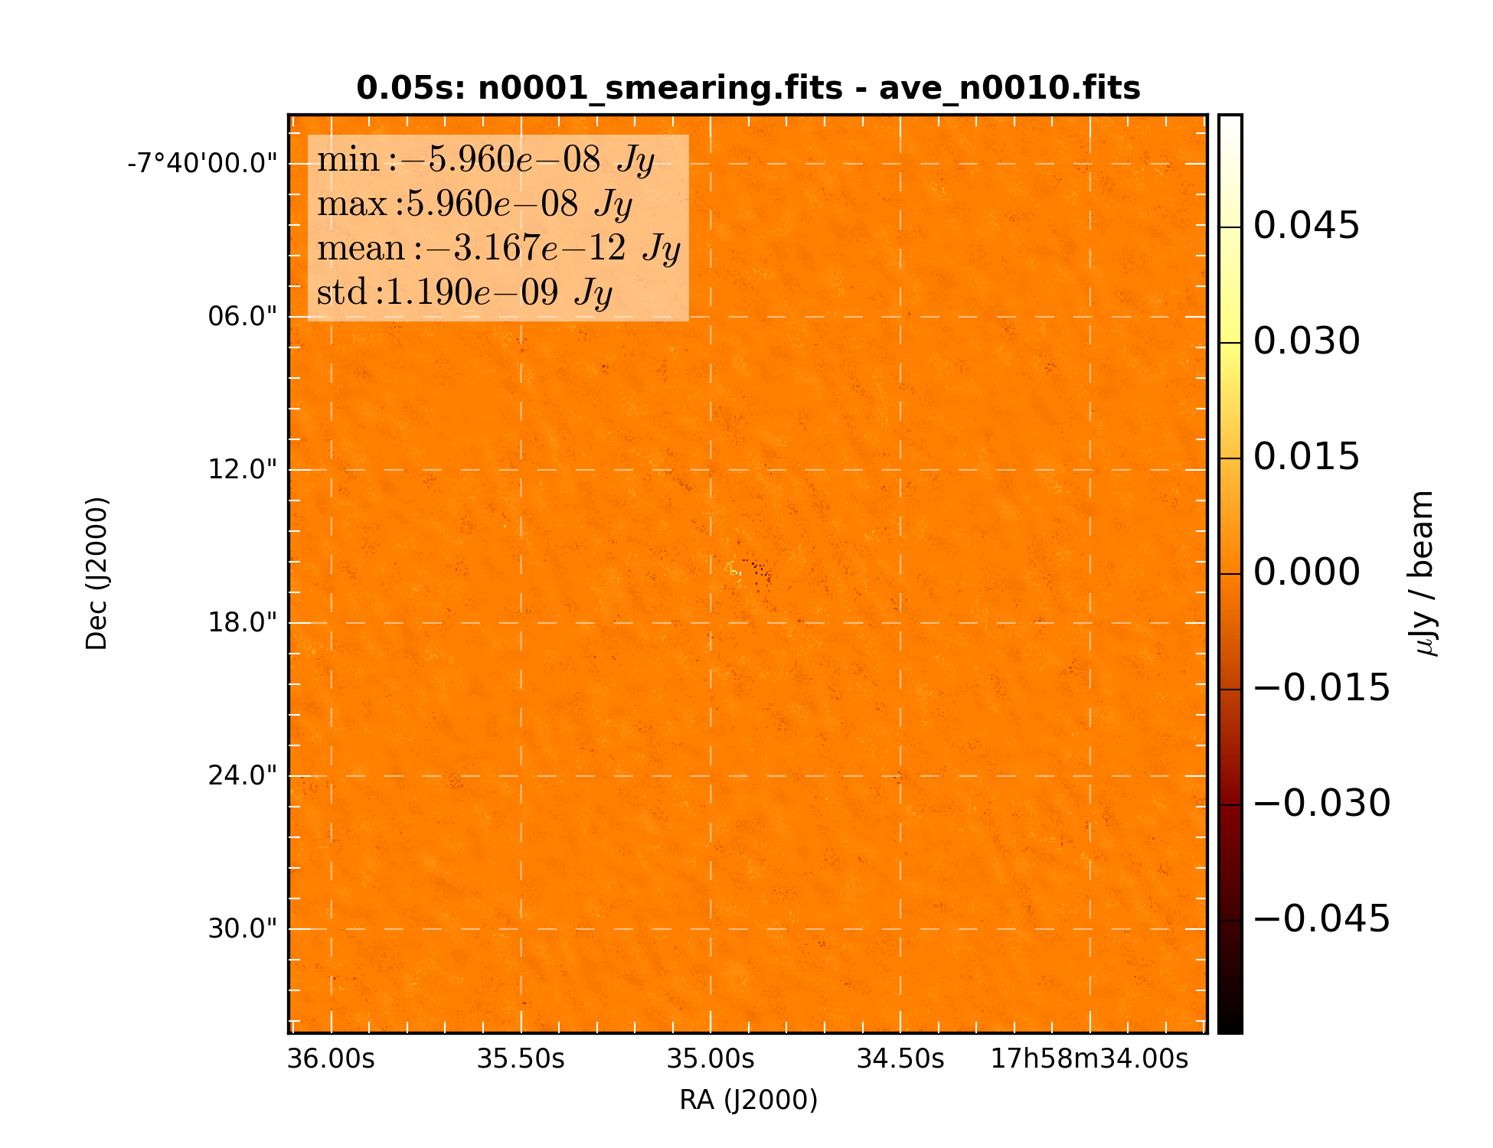

Figure 7: Difference of snapshot dirty image with average of 10 sub-samples.

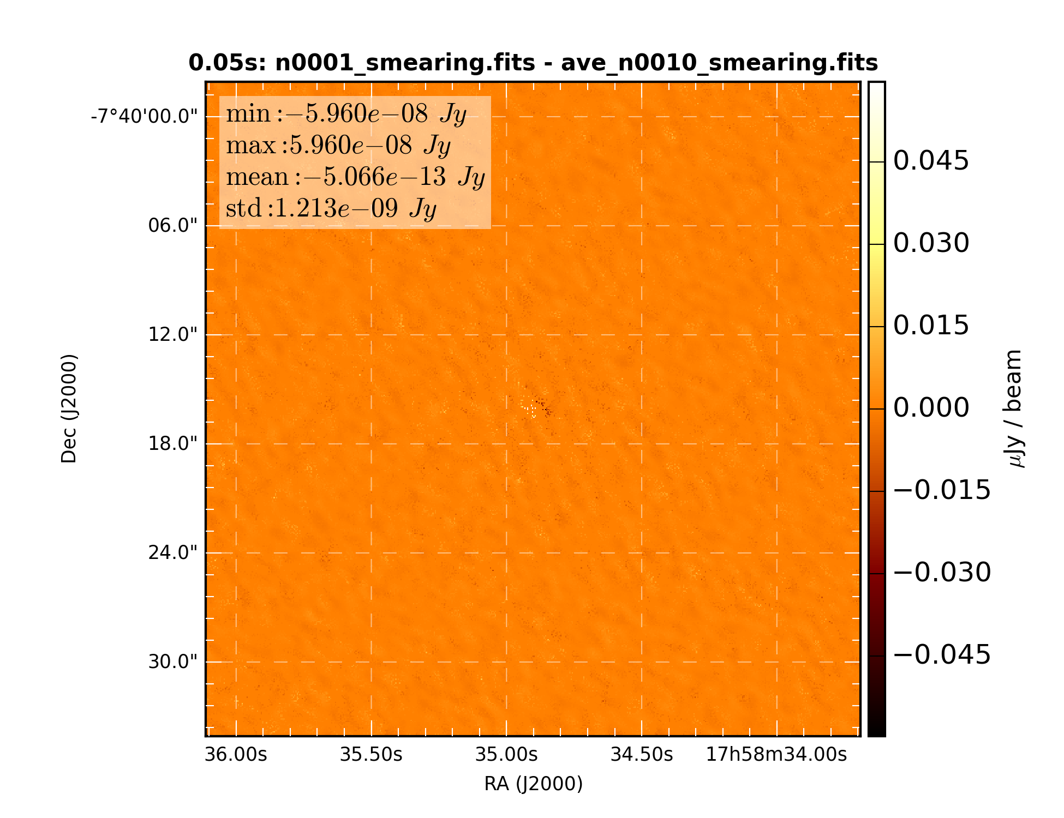

Figure 8: Difference of snapshot dirty image with average of 10 time smearing corrected sub-samples.

### Average of 1000 snapshots

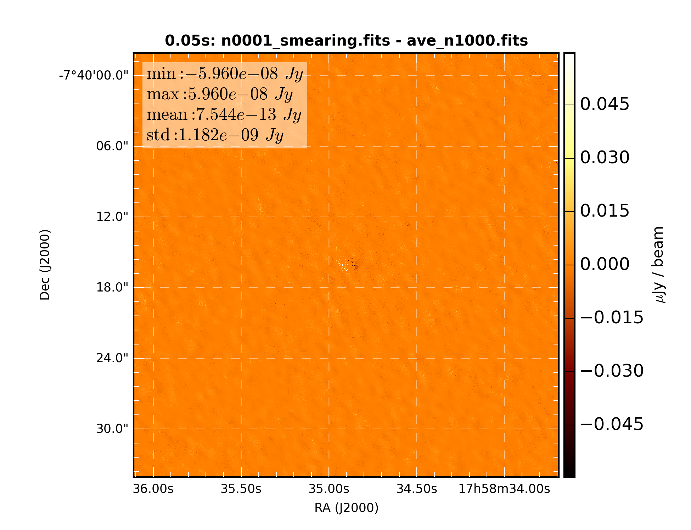

Figure 9: Difference of snapshot dirty image with average of 1000 sub-samples.

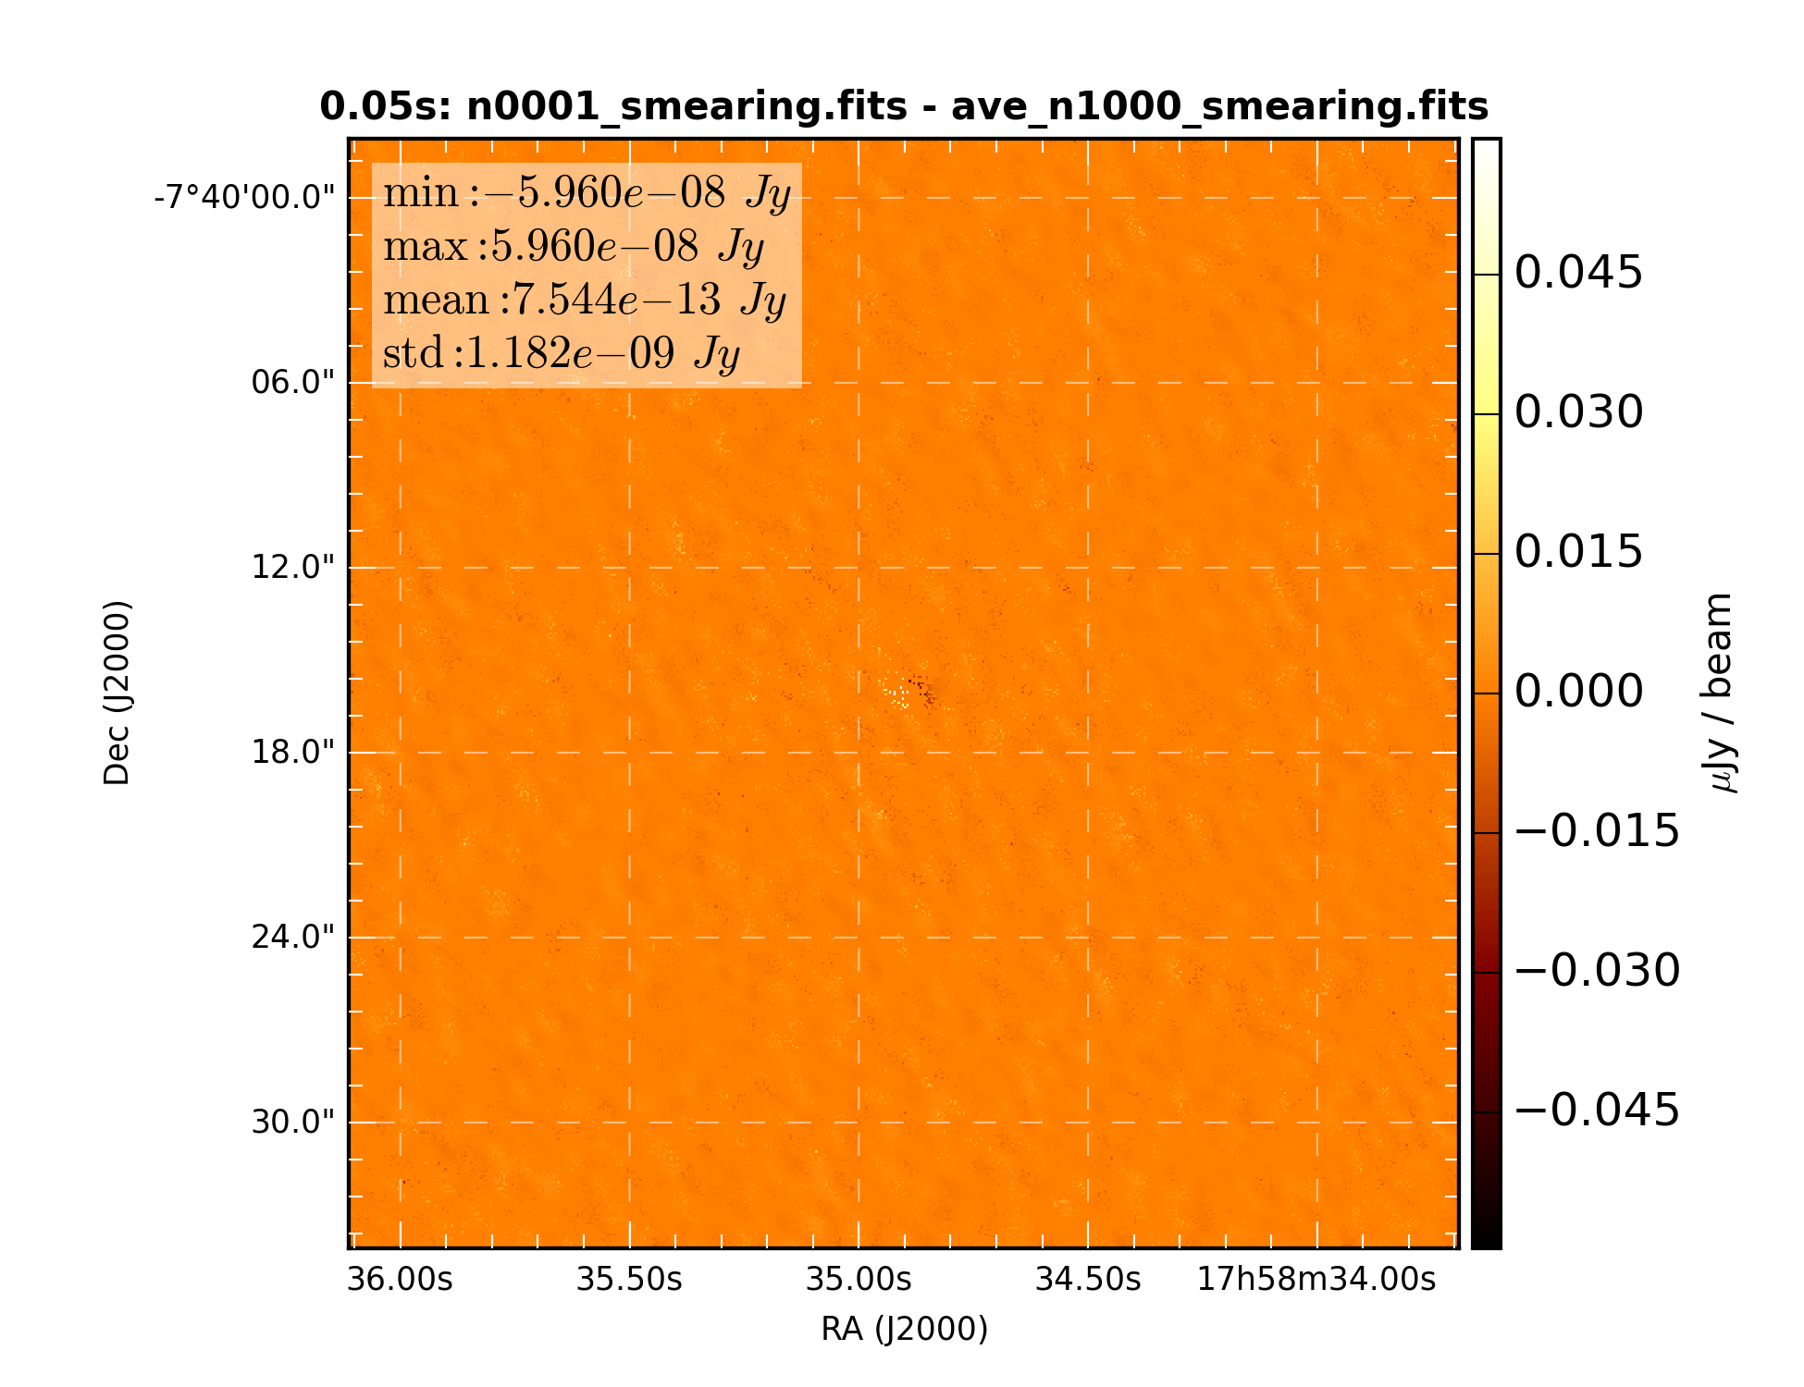

Figure 10: Difference of snapshot dirty image with average of 1000 time smearing corrected sub-samples.

## Simulation 2: 0.1 second correlator dump time

### 1 snapshot

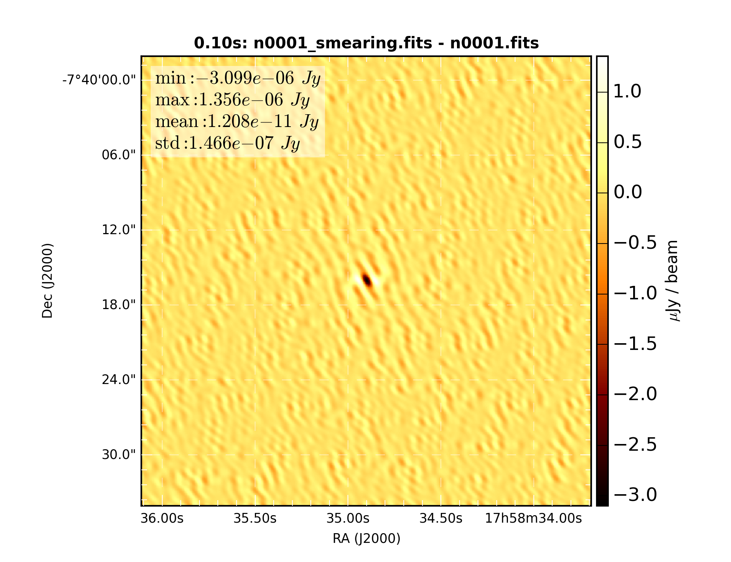

Figure 11: Difference of snapshot dirty images with and without time smearing correction

### Average of 2 snapshots

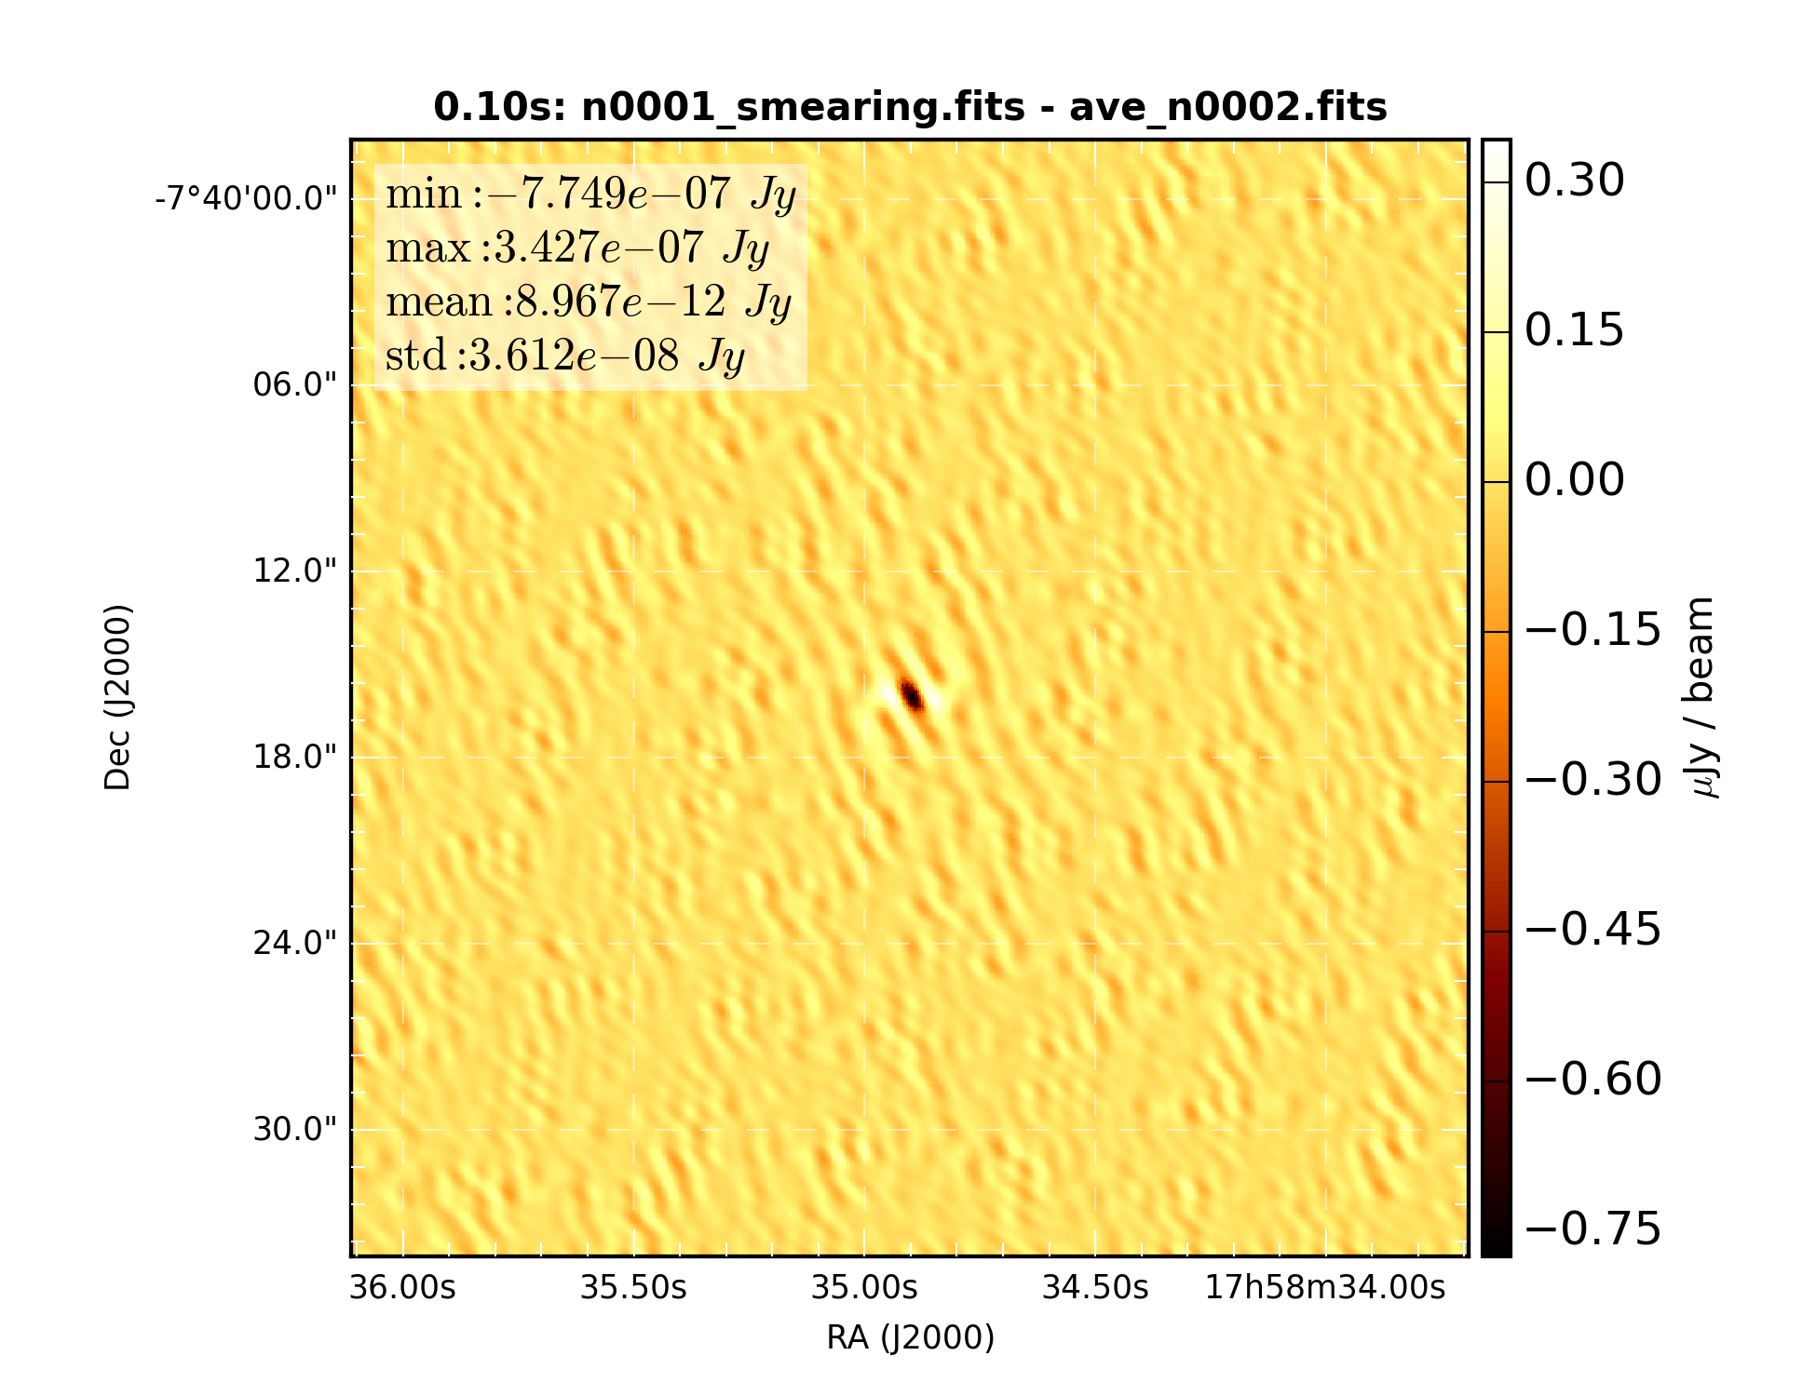

Figure 12: Difference of snapshot dirty image with average of 2 sub-samples

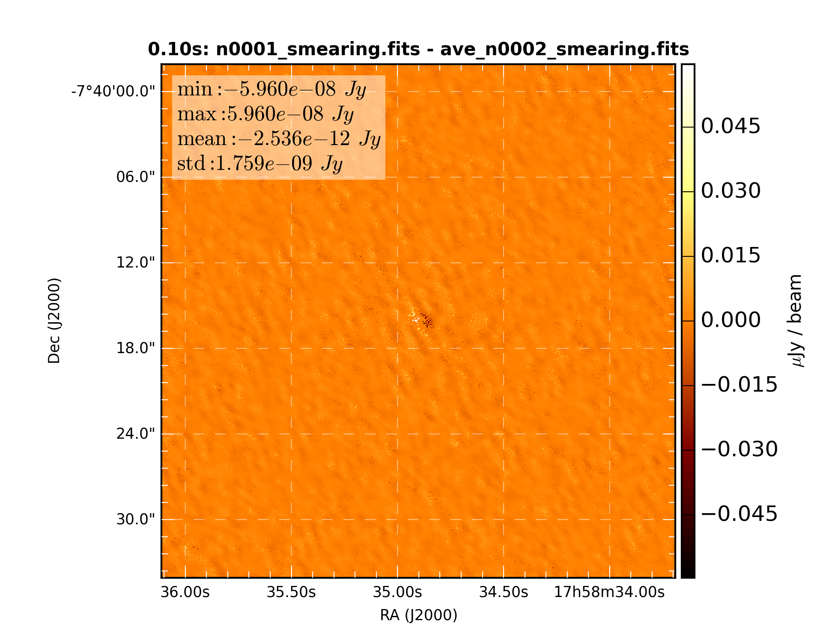

Figure 13: Difference of snapshot dirty image with average of 2 time smearing corrected sub-samples

### Average of 10 snapshots

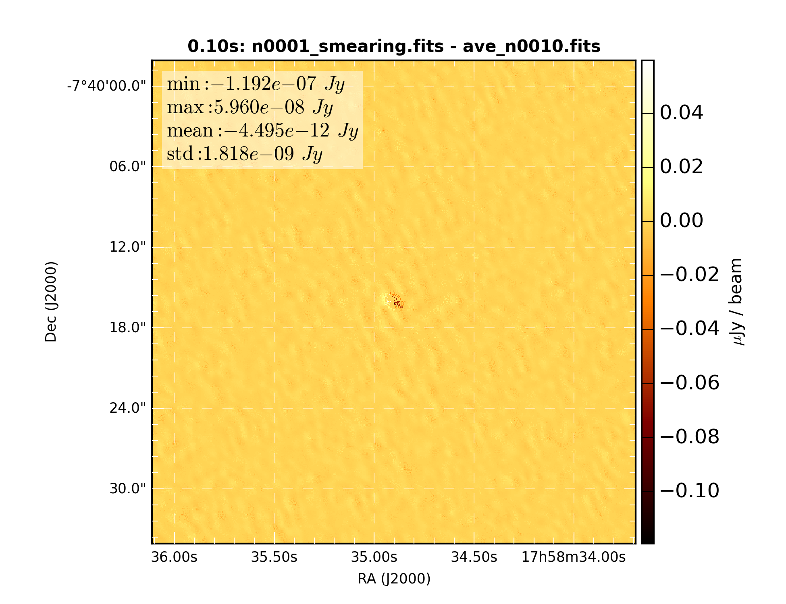

Figure 14

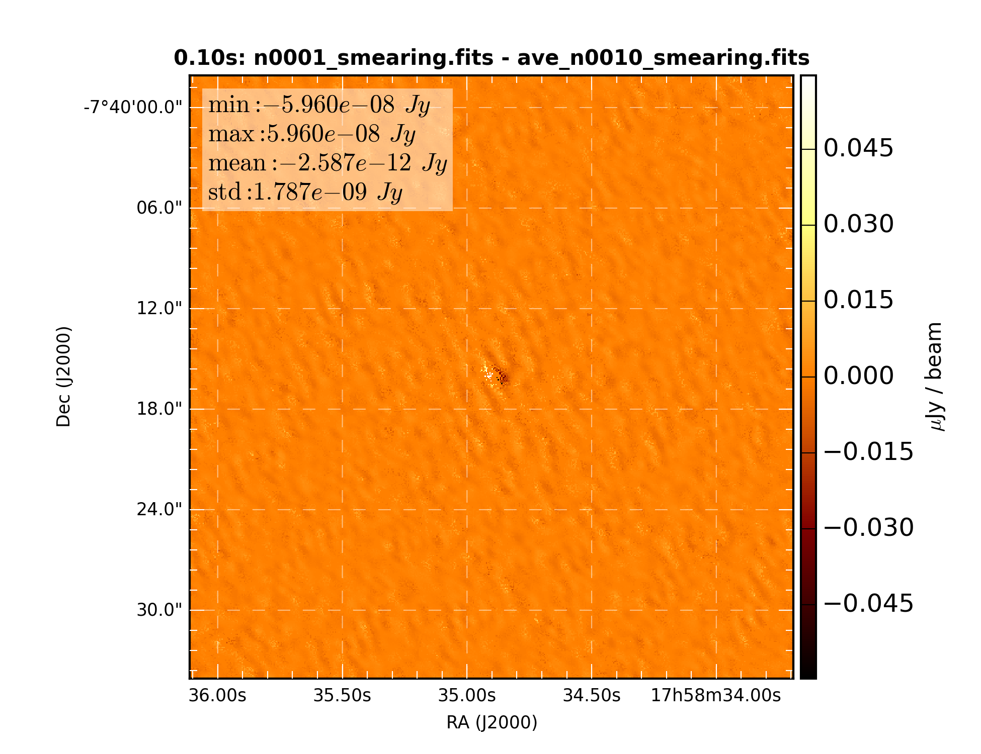

Figure 15: Difference of snapshot dirty image with average of 10 time smearing corrected sub-samples

### Average of 1000 snapshots

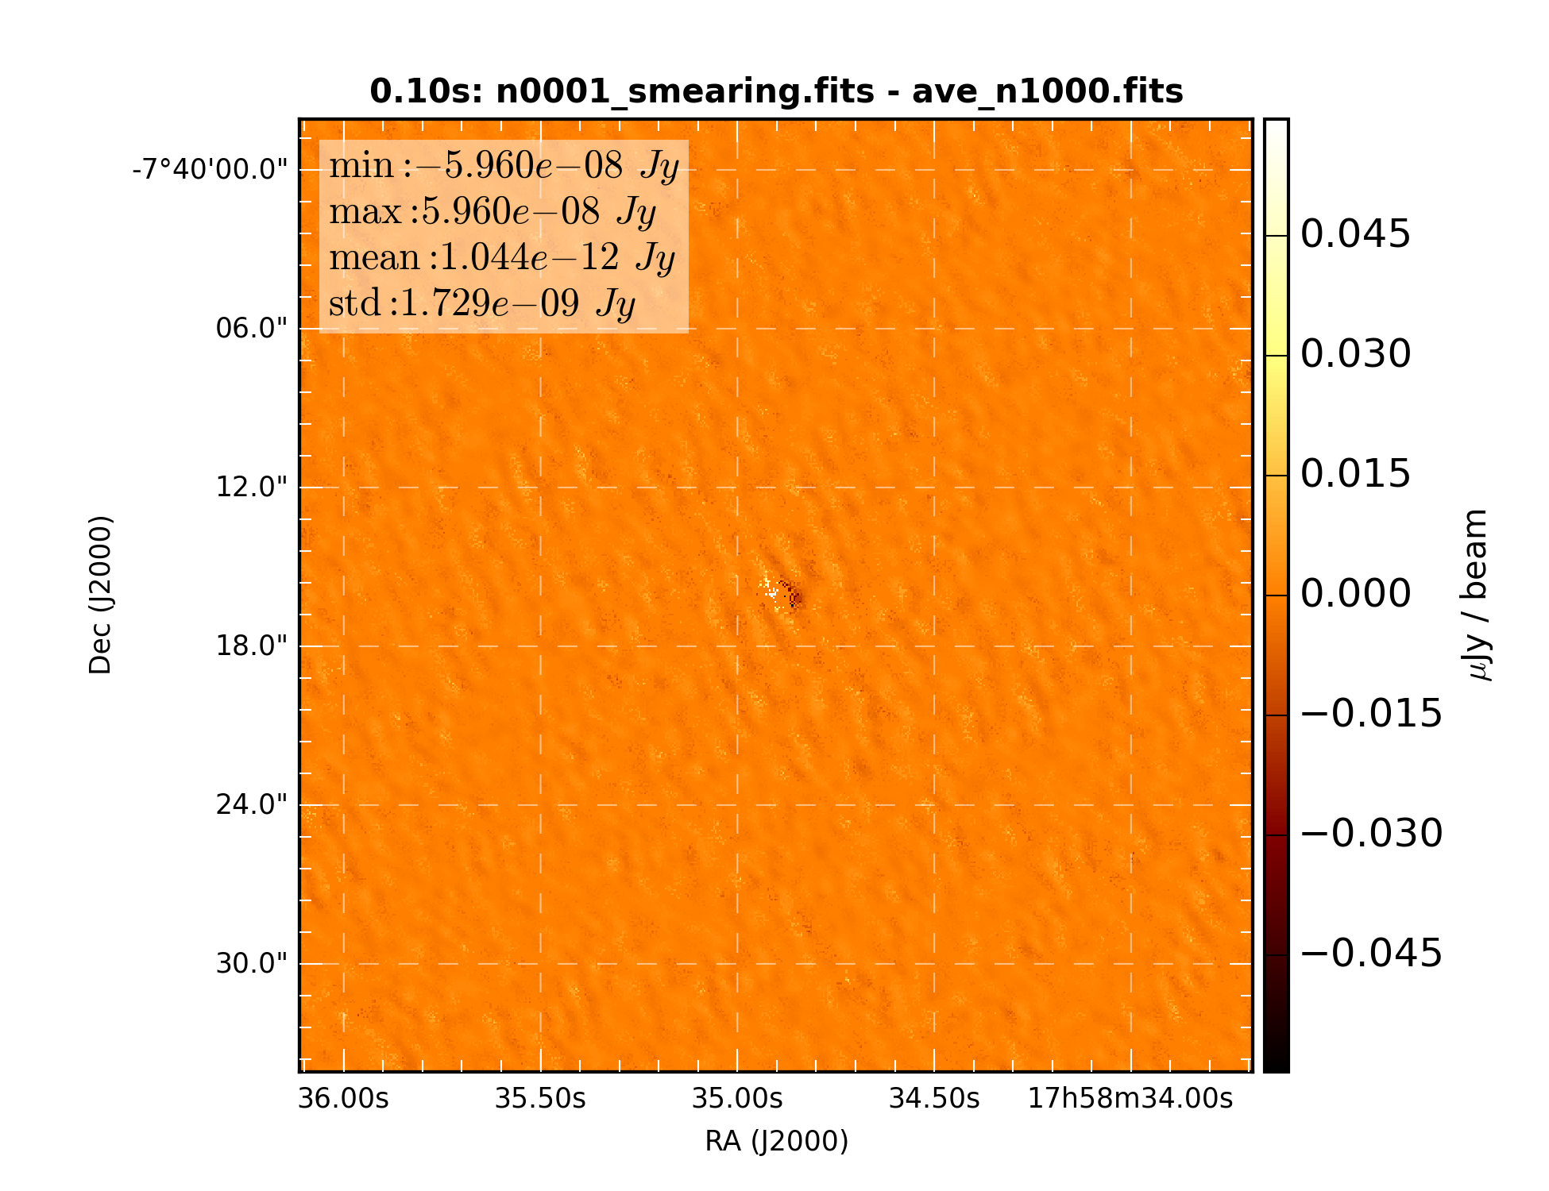

Figure 16

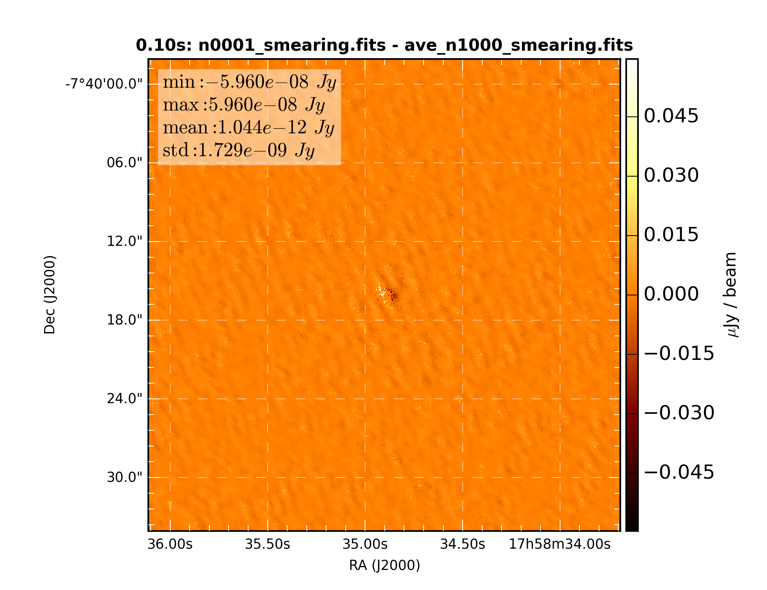

Figure 17: Difference of snapshot dirty image with average of 2 time smearing corrected sub-samples

## Simulation 4: 0.5 second correlator dump time

### 1 snapshot

### 

Figure 18: Difference of snapshot dirty images with and without time smearing correction

### Average of 2 snapshots

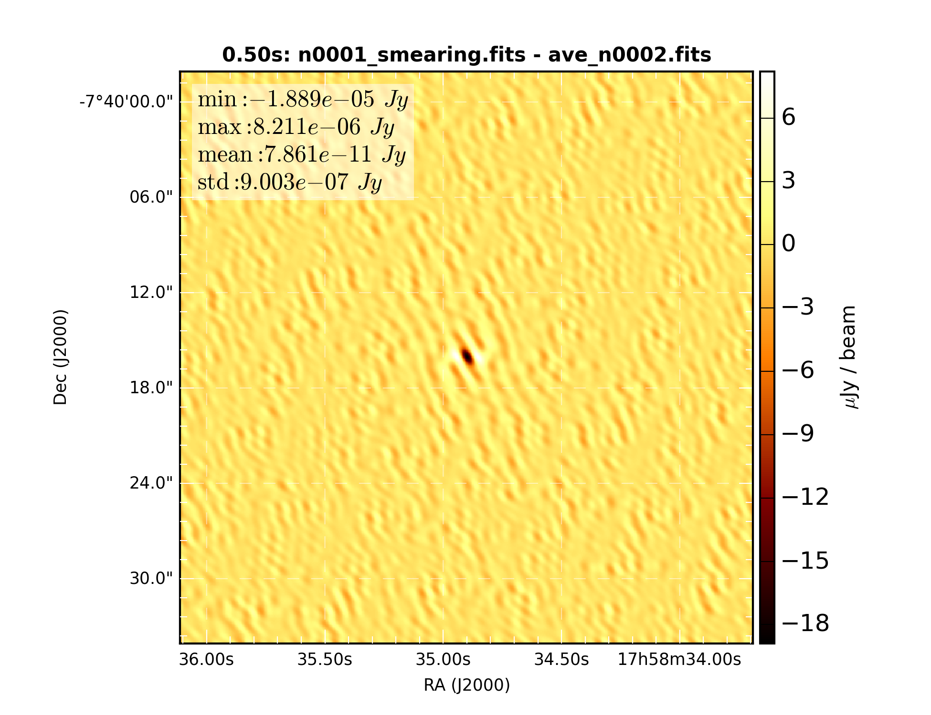

Figure 19: Difference of snapshot dirty image with average of 2 sub-samples

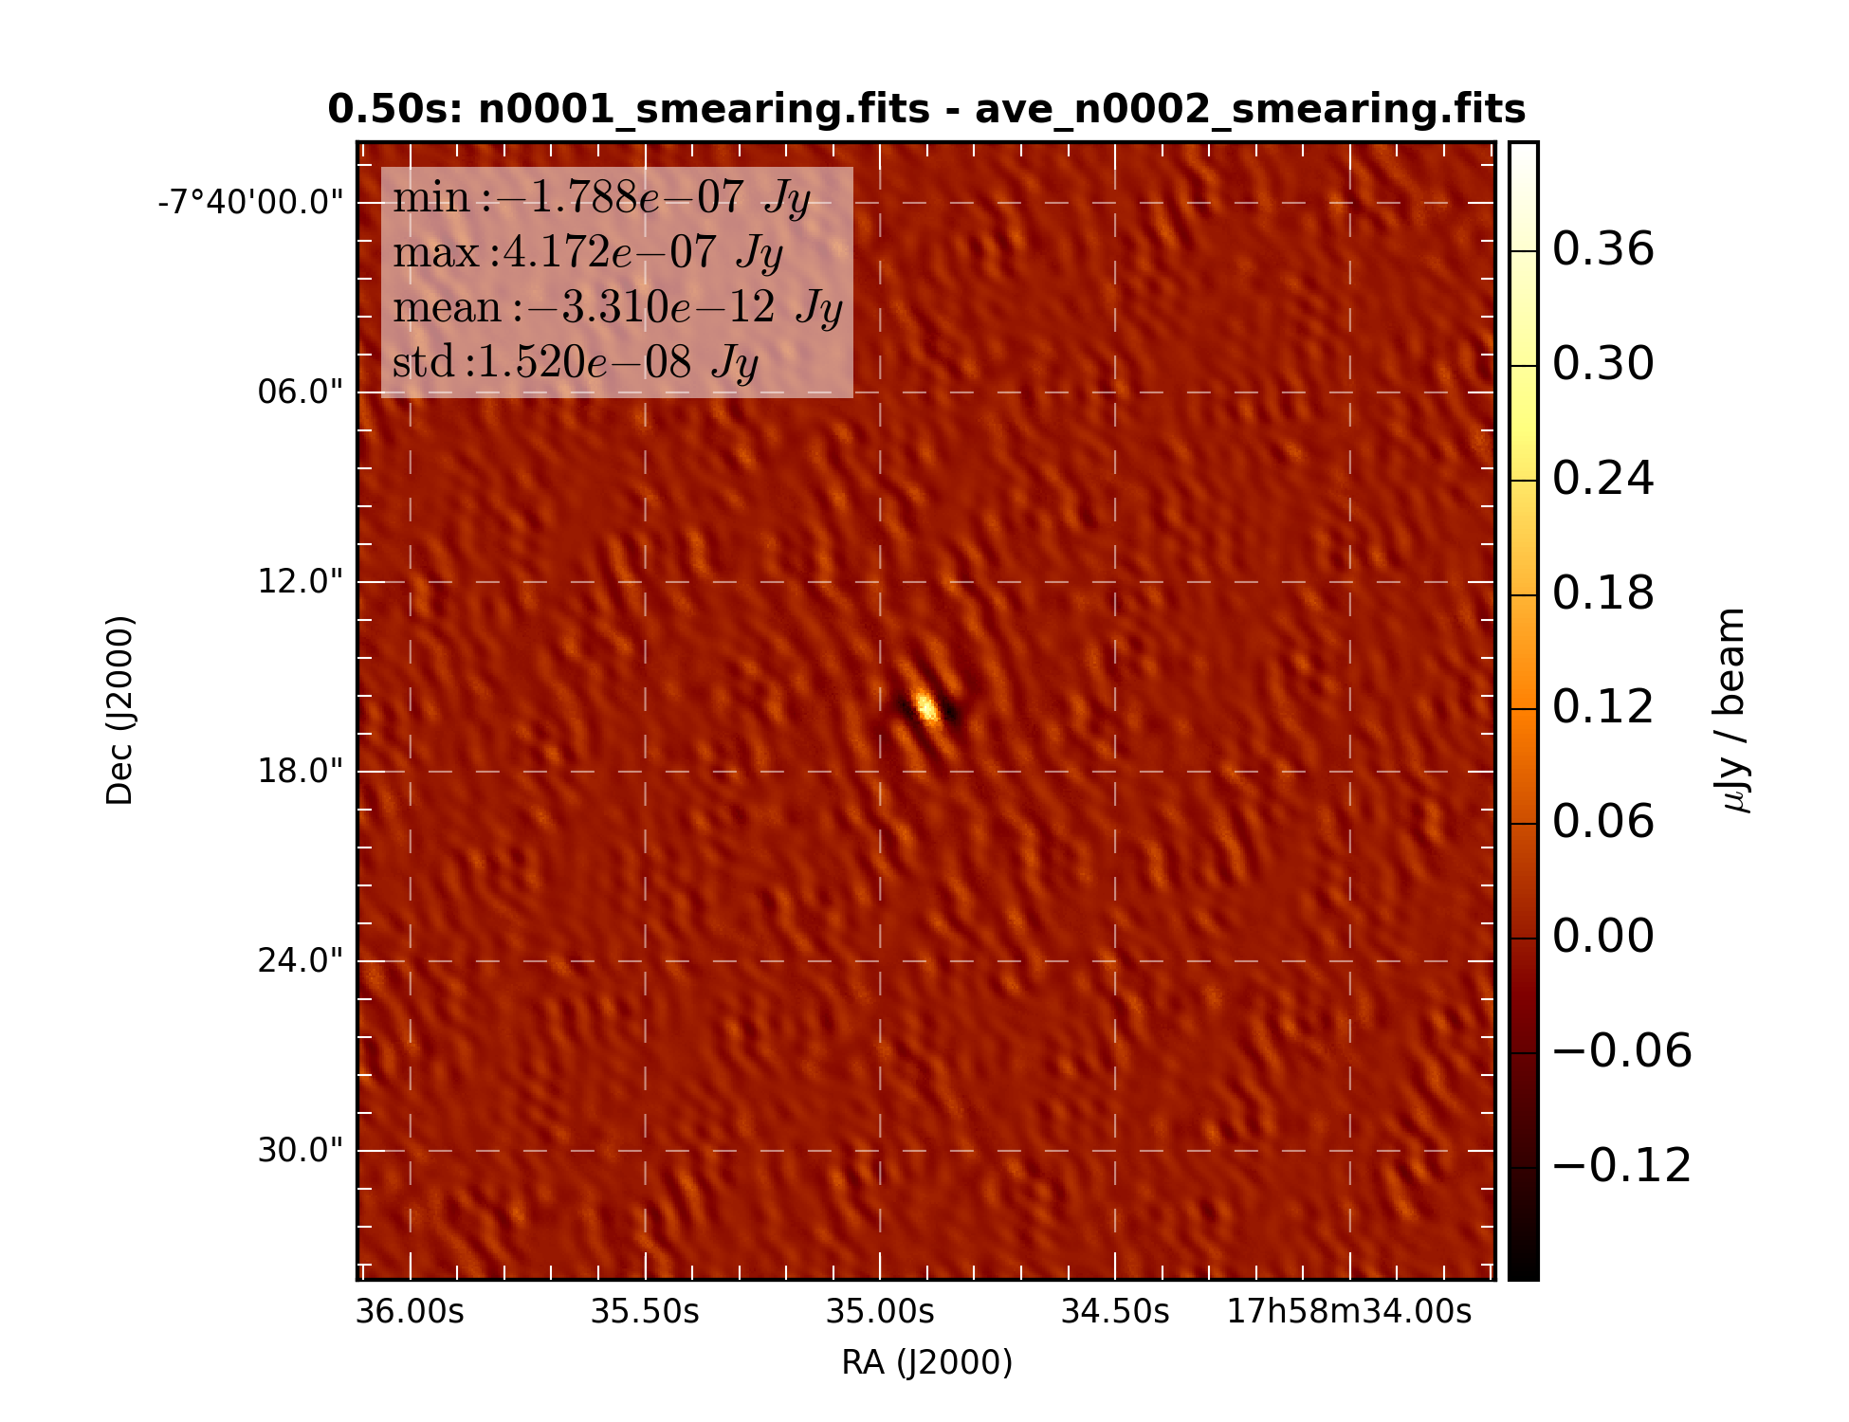

Figure 20: Difference of snapshot dirty image with average of 2 time smearing corrected sub-samples

### Average of 10 snapshots

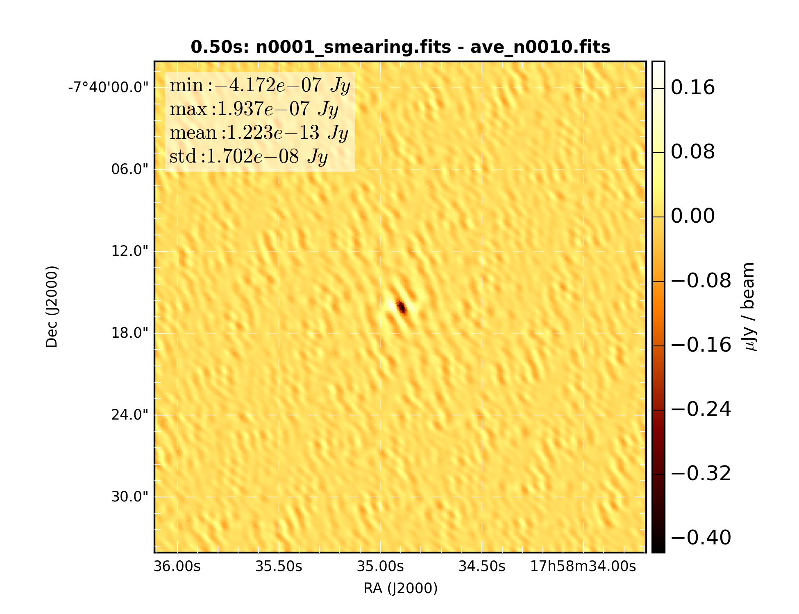

Figure 21: Difference of snapshot dirty image with average of 10 sub-samples

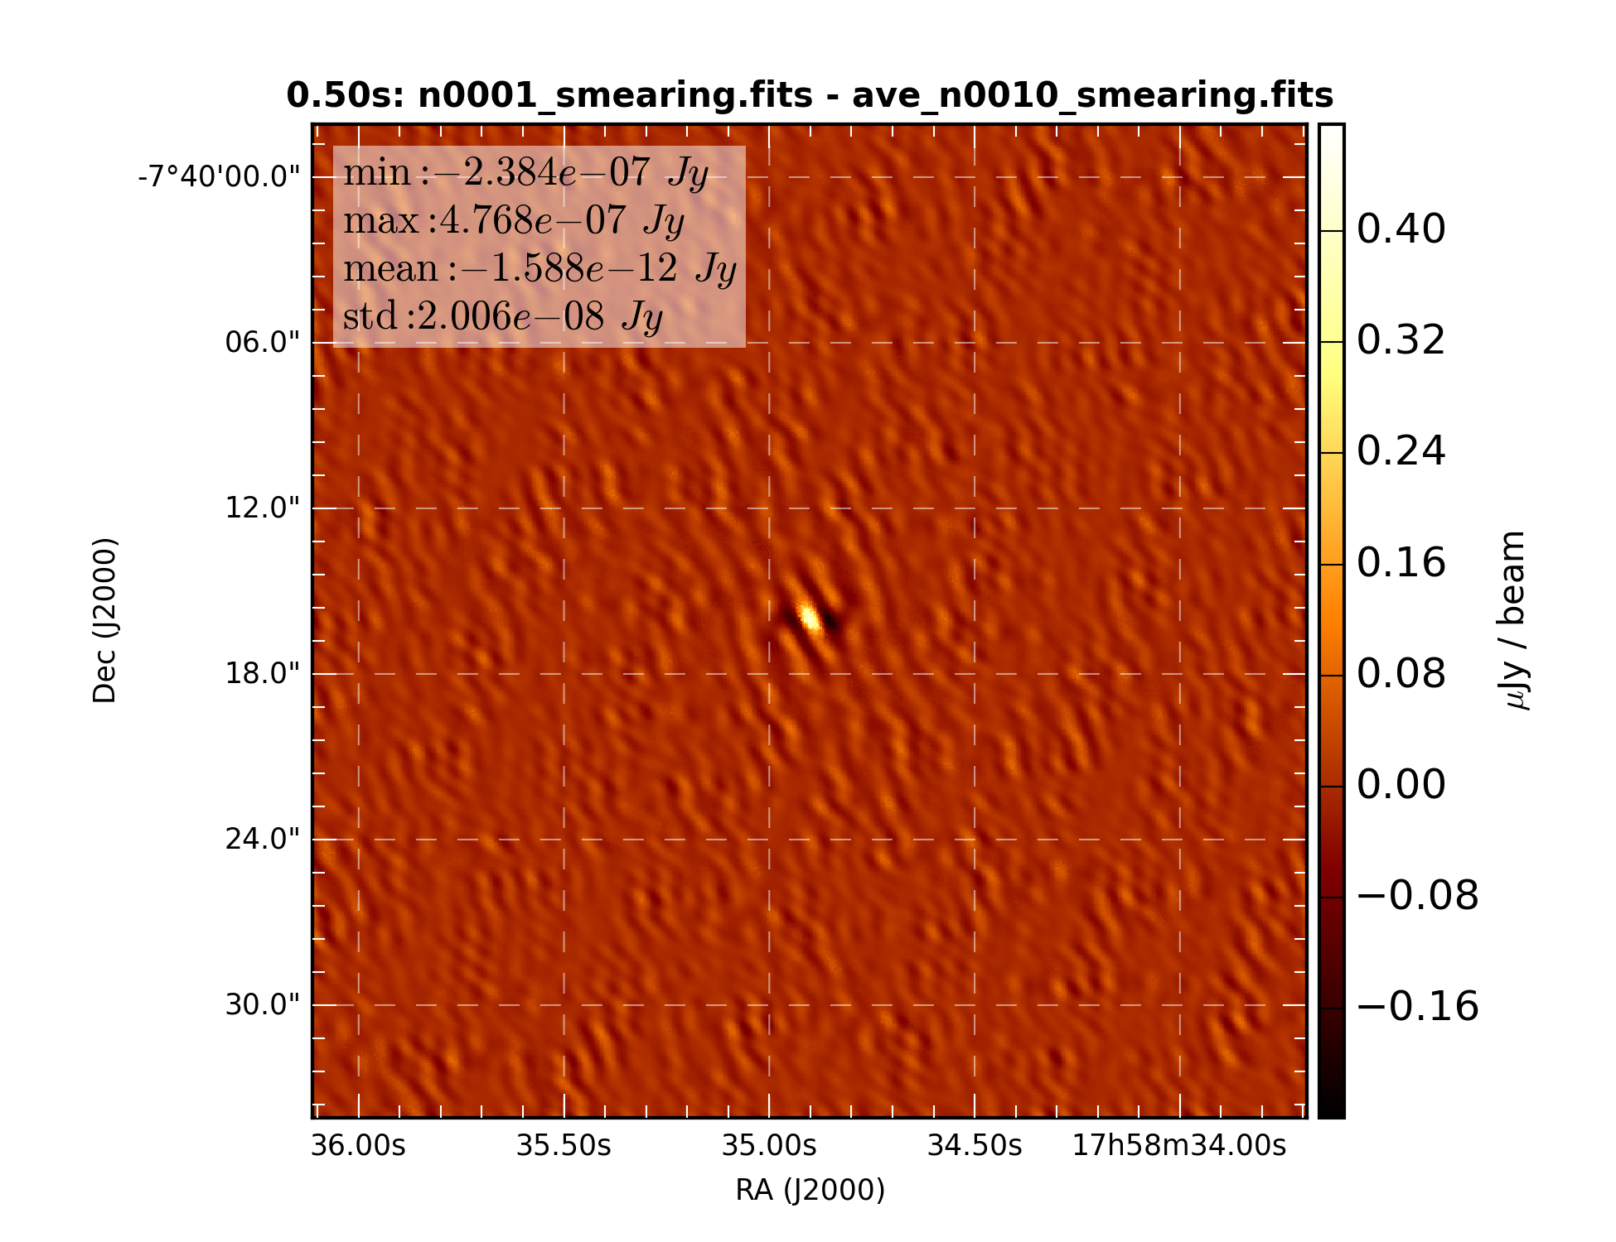

Figure 22: Difference of snapshot dirty image with average of 10 time smearing corrected sub-samples

### Average of 1000 snapshots

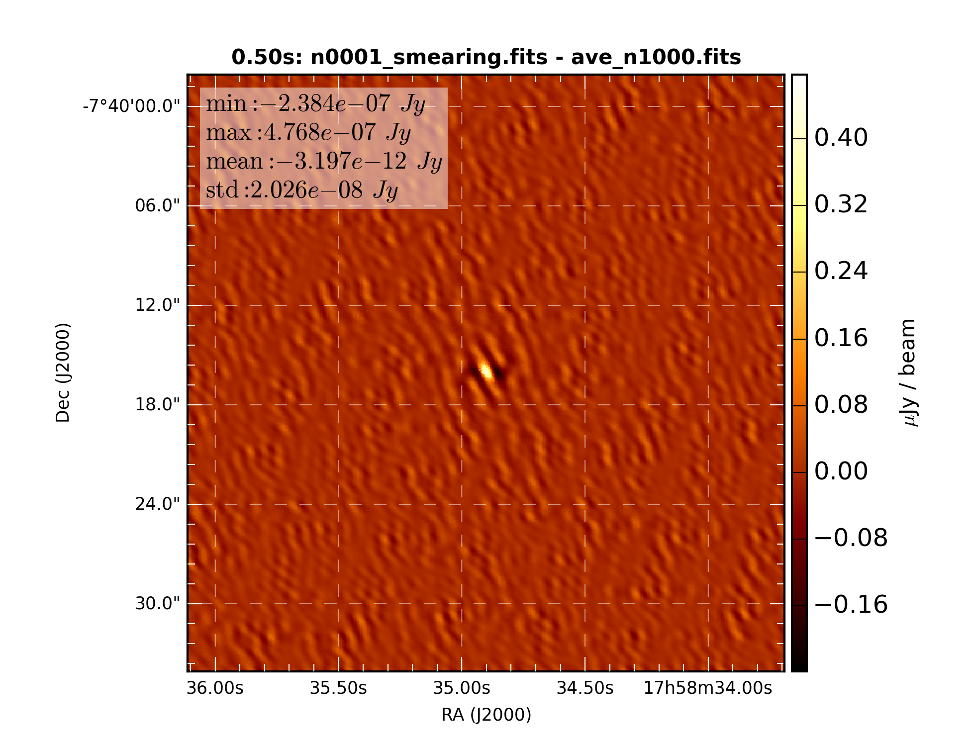

Figure 23: Difference of snapshot dirty image with average of 1000 sub-samples

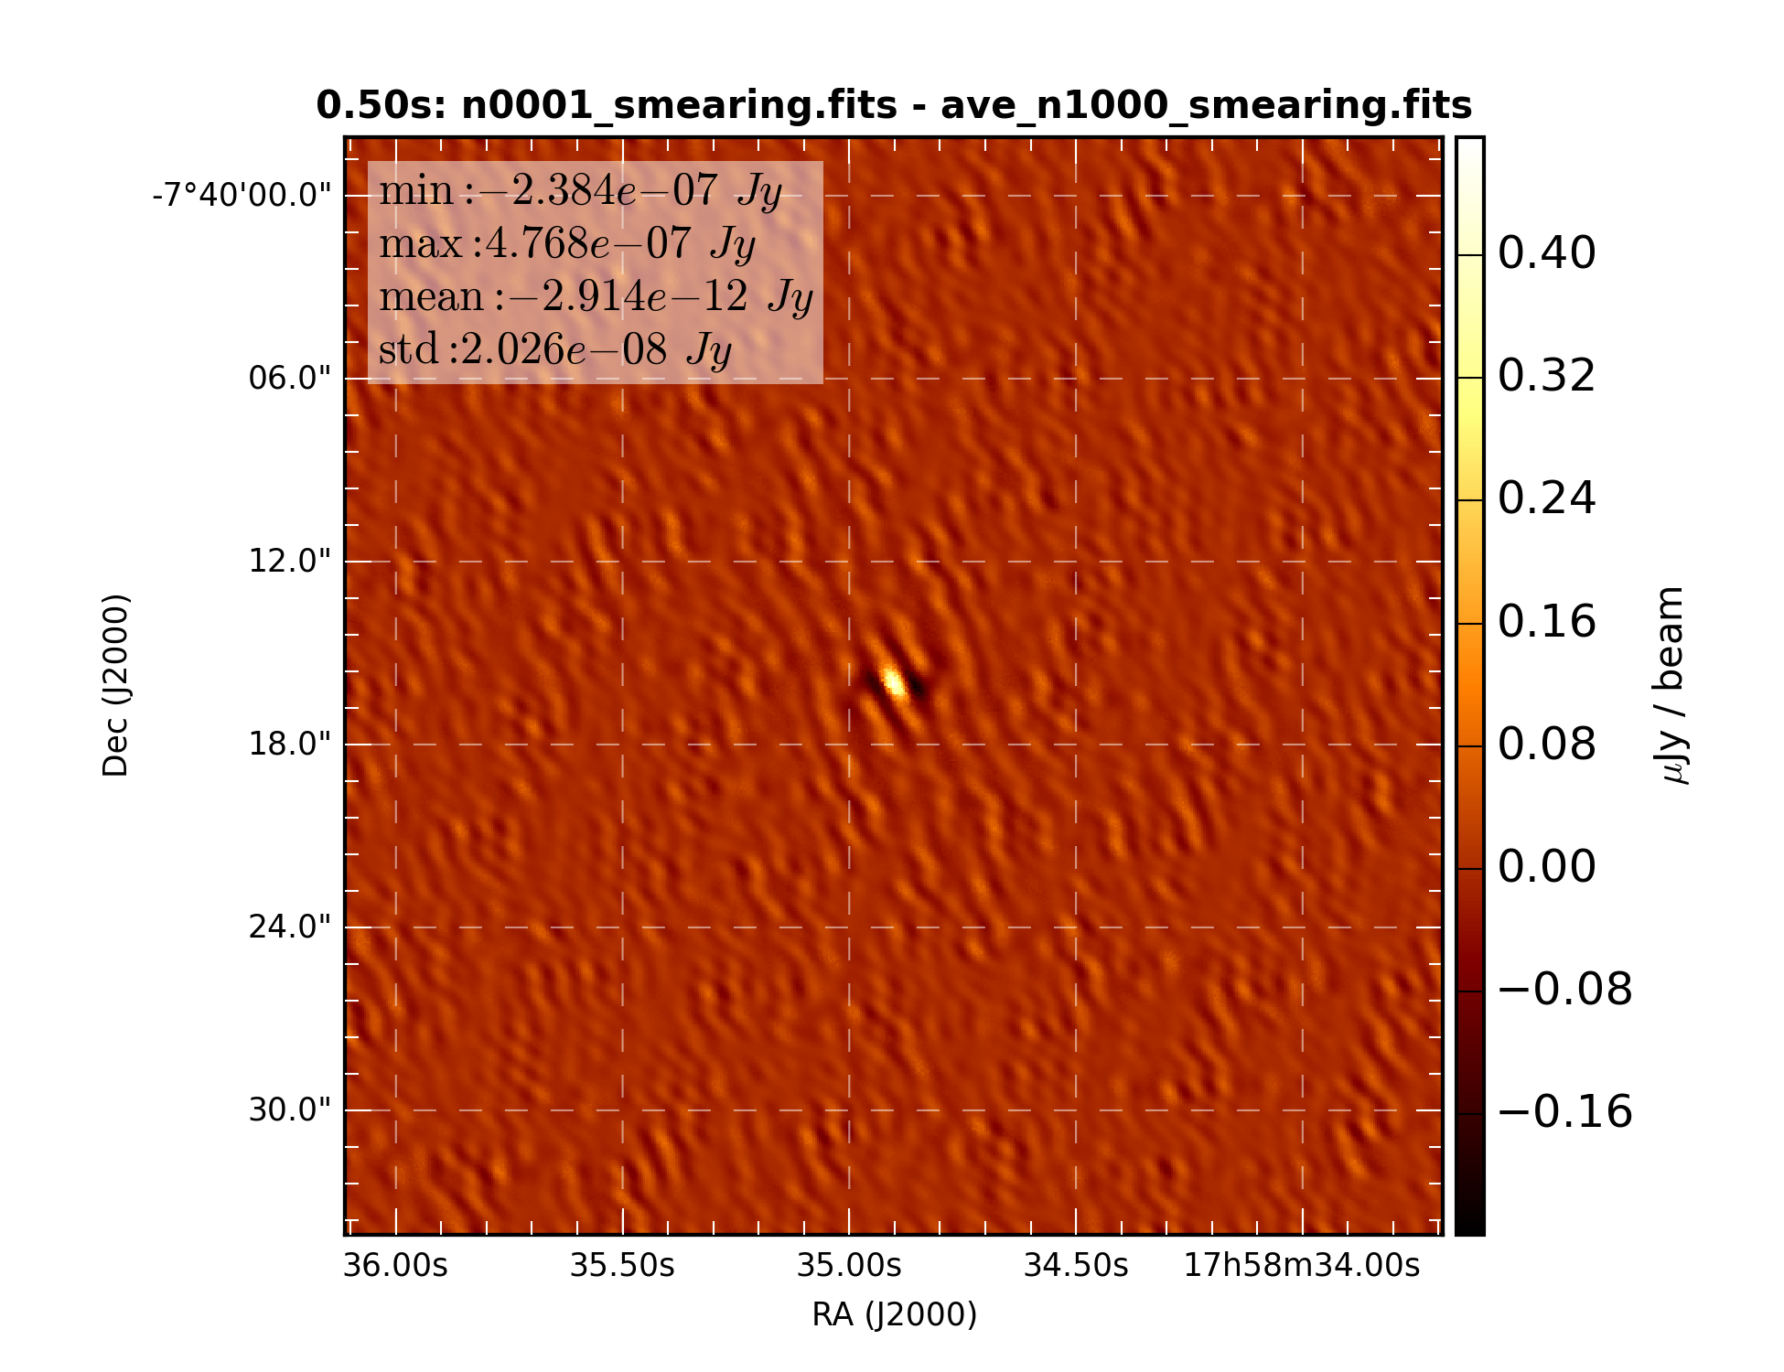

Figure 24: Difference of snapshot dirty image with average of 1000 time smearing corrected sub-samples

## Simulation 4: 1.0 second correlator dump time

### 1 snapshot

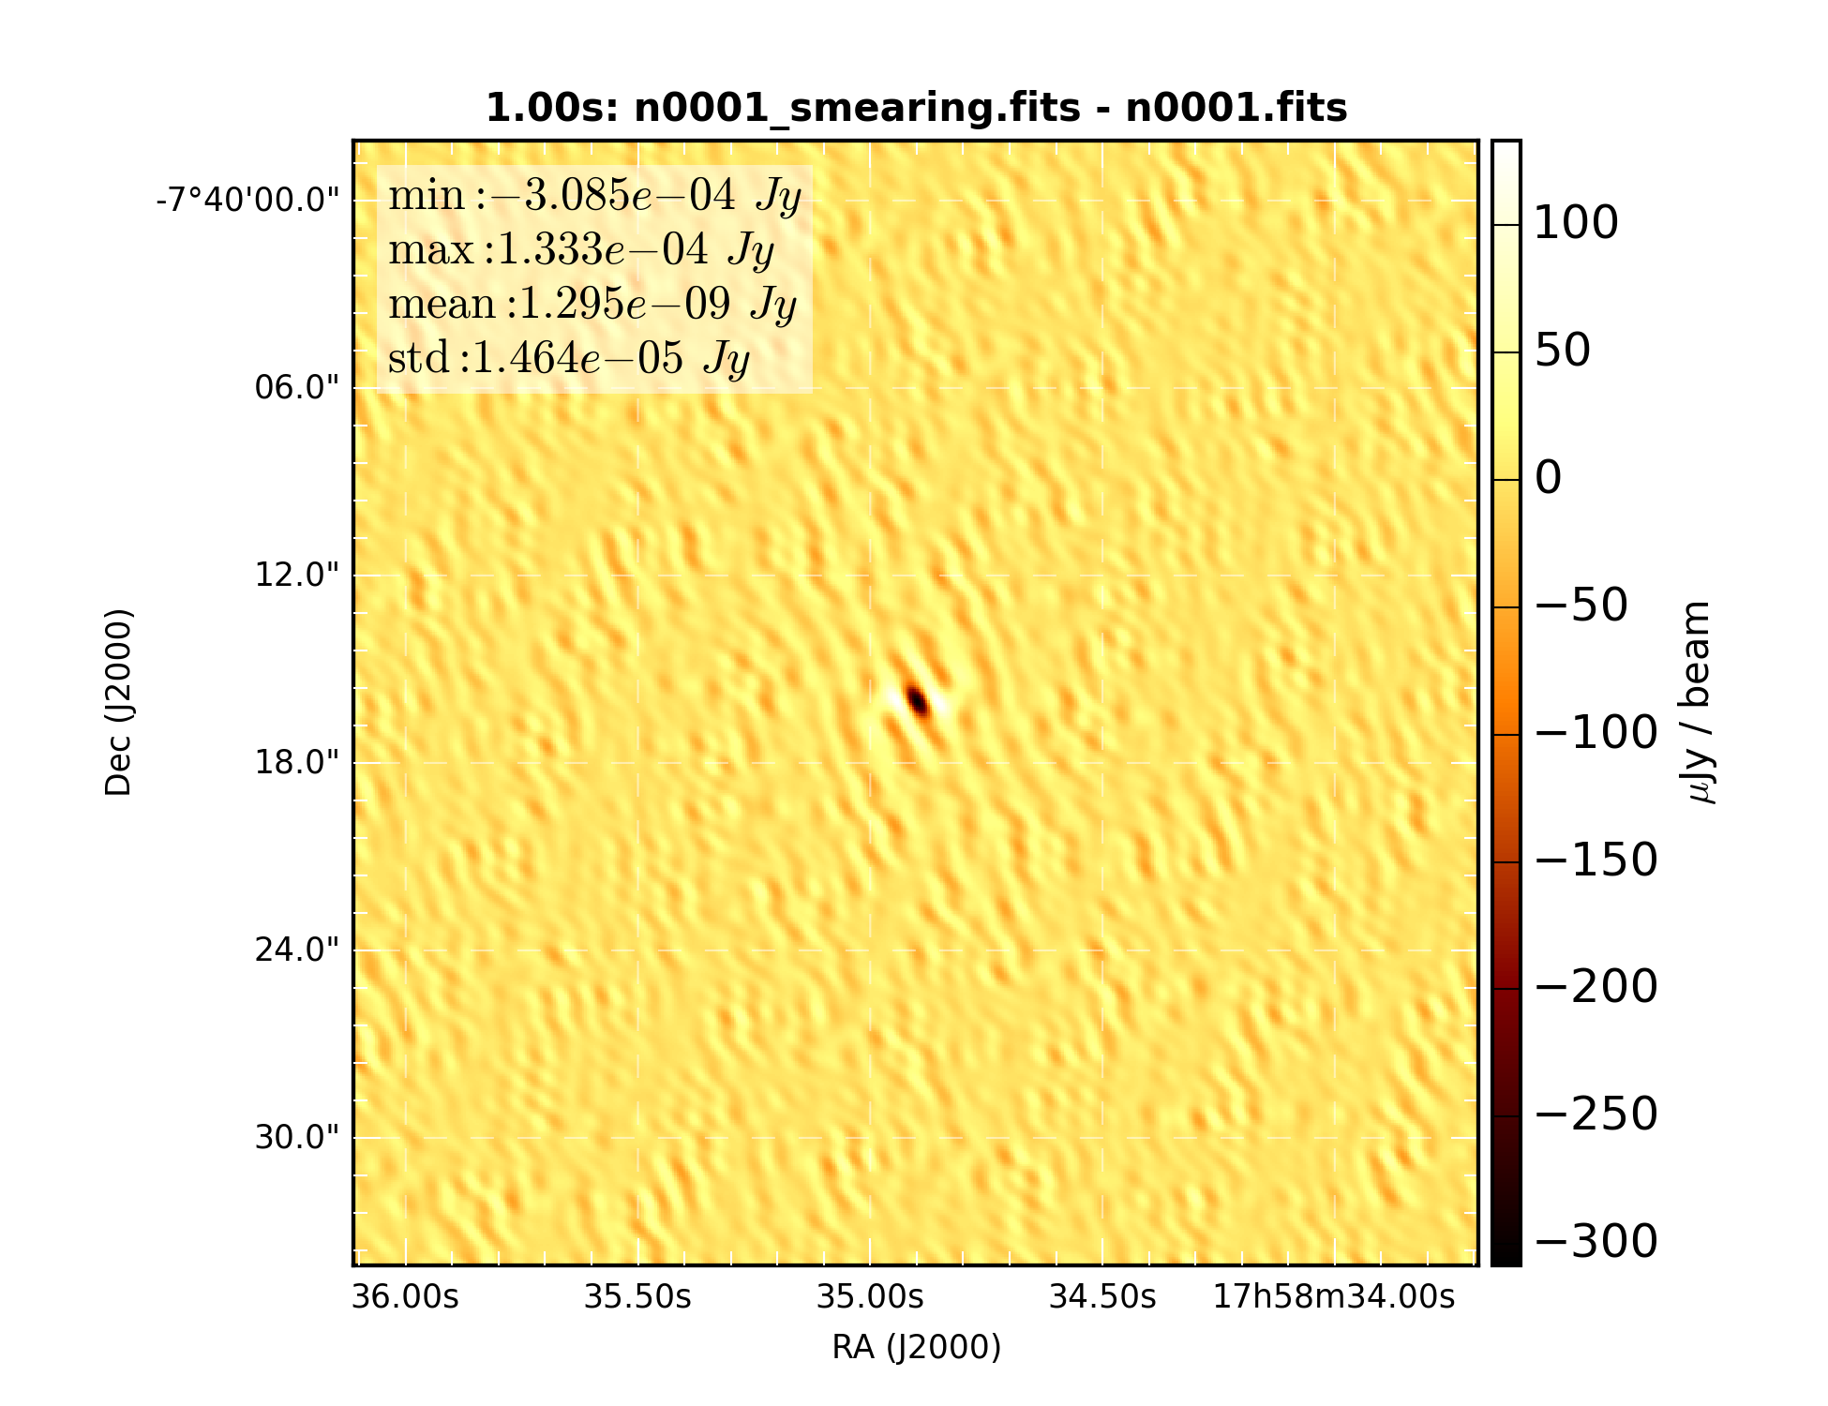

Figure 25: Difference of snapshot dirty images with and without time smearing correction

### Average of 2 snapshots

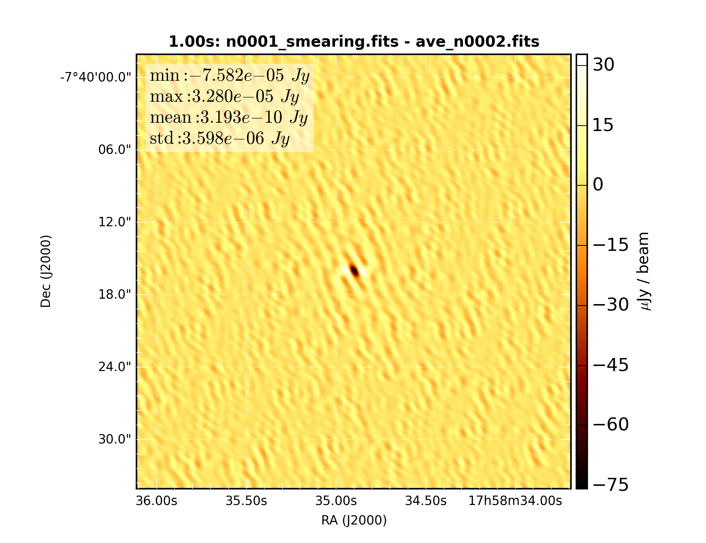

Figure 26: Difference of snapshot dirty image with average of 2 sub-samples

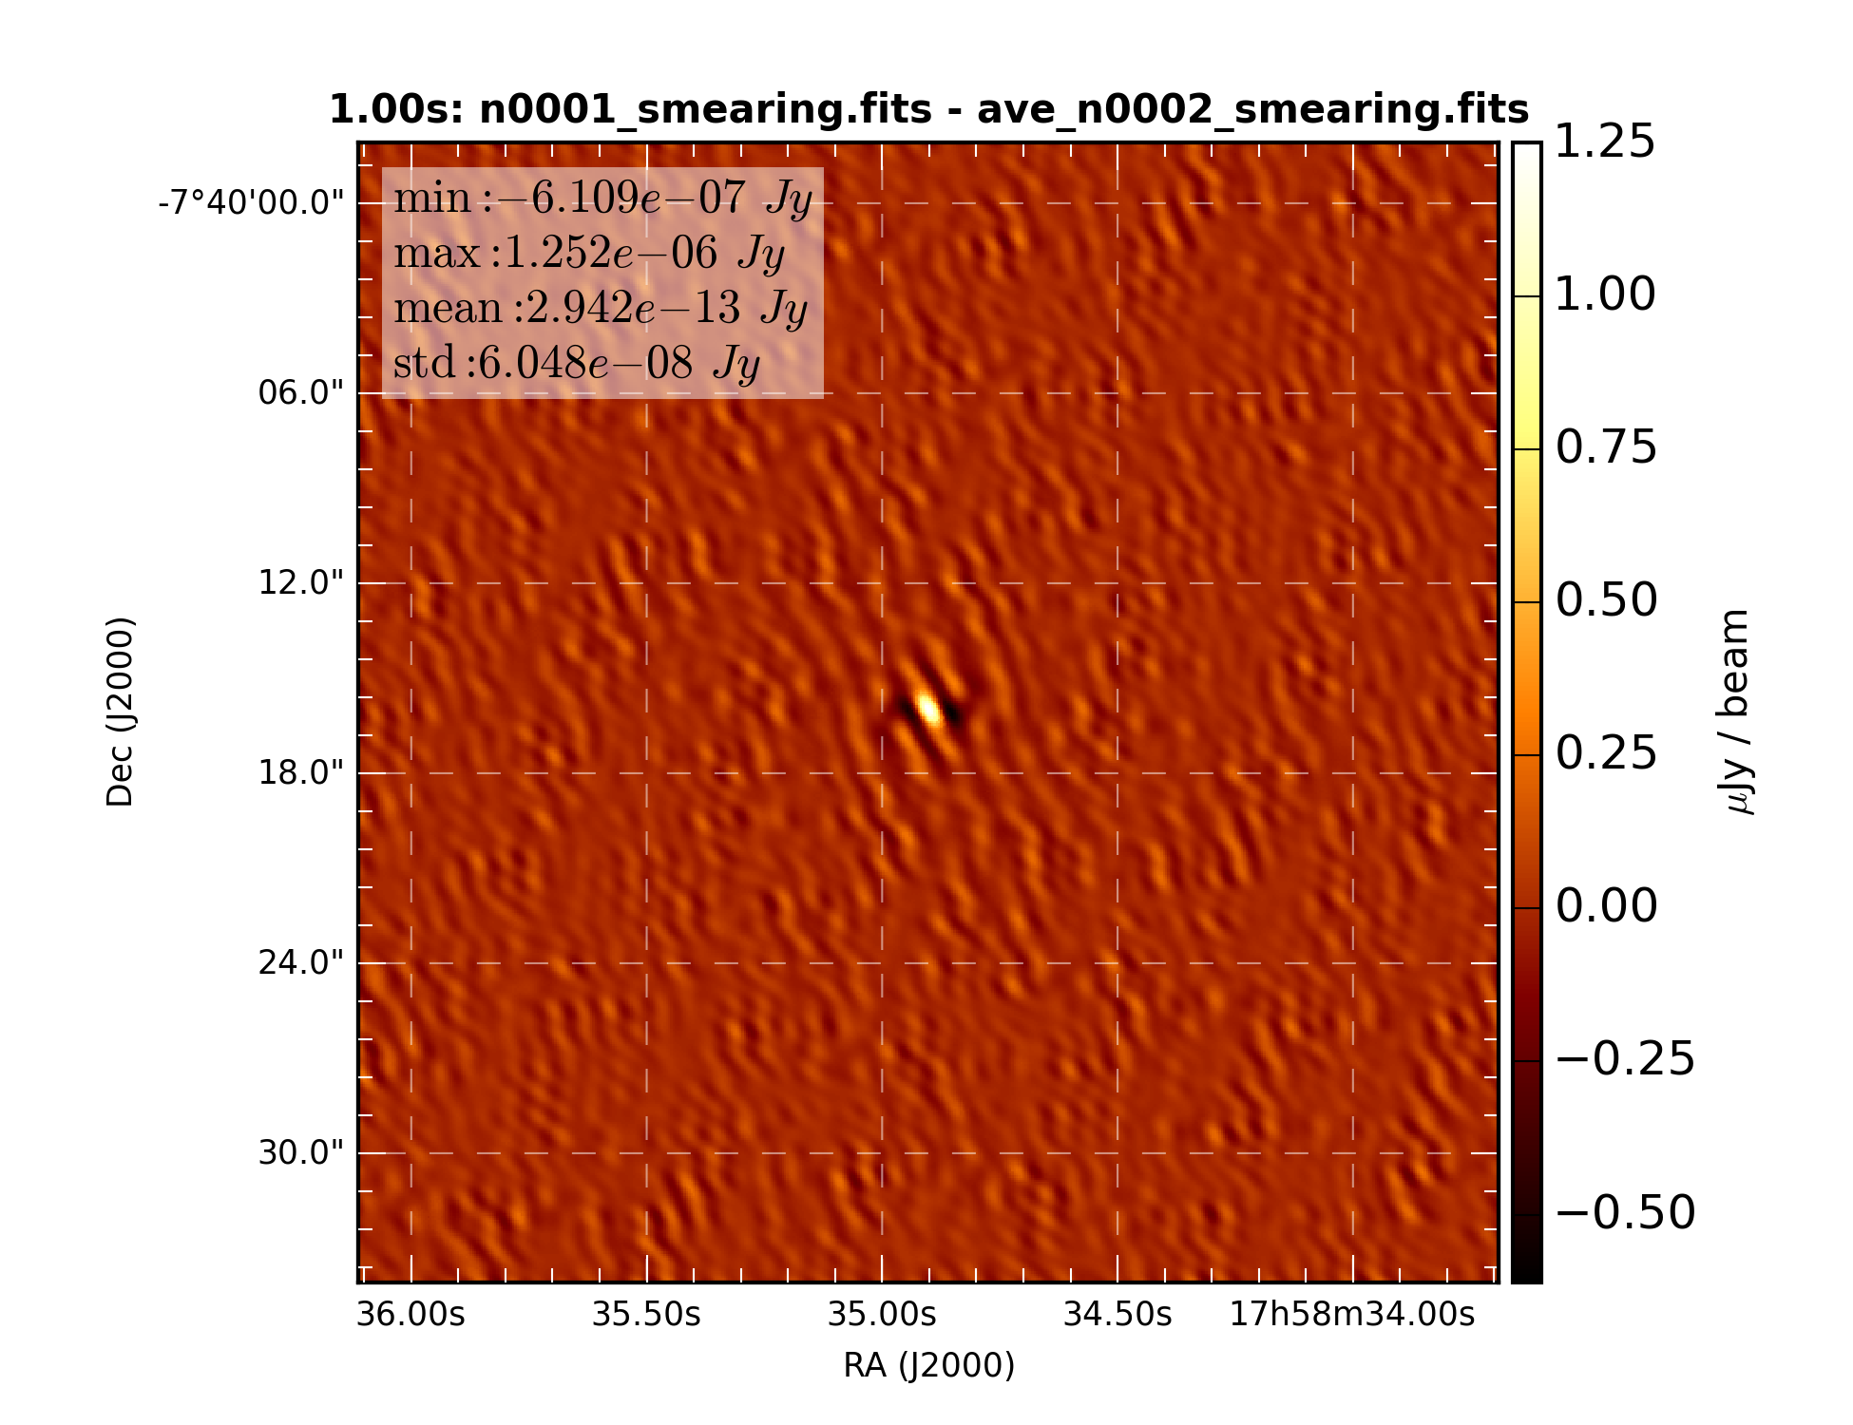

Figure 27: Difference of snapshot dirty image with average of 2 time smearing corrected sub-samples

### Average of 10 snapshots

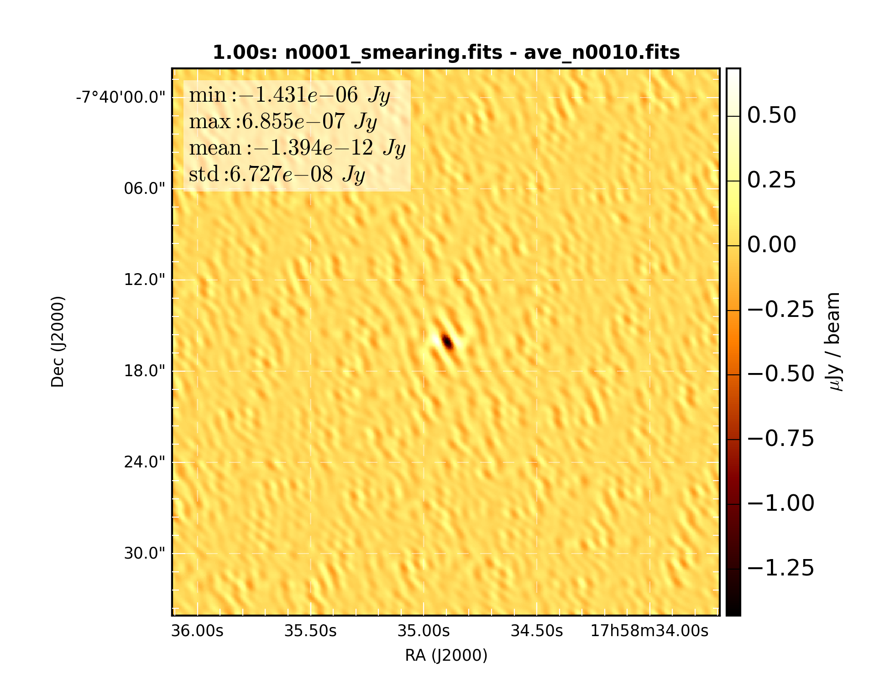

Figure 28: Difference of snapshot dirty image with average of 10 sub-samples

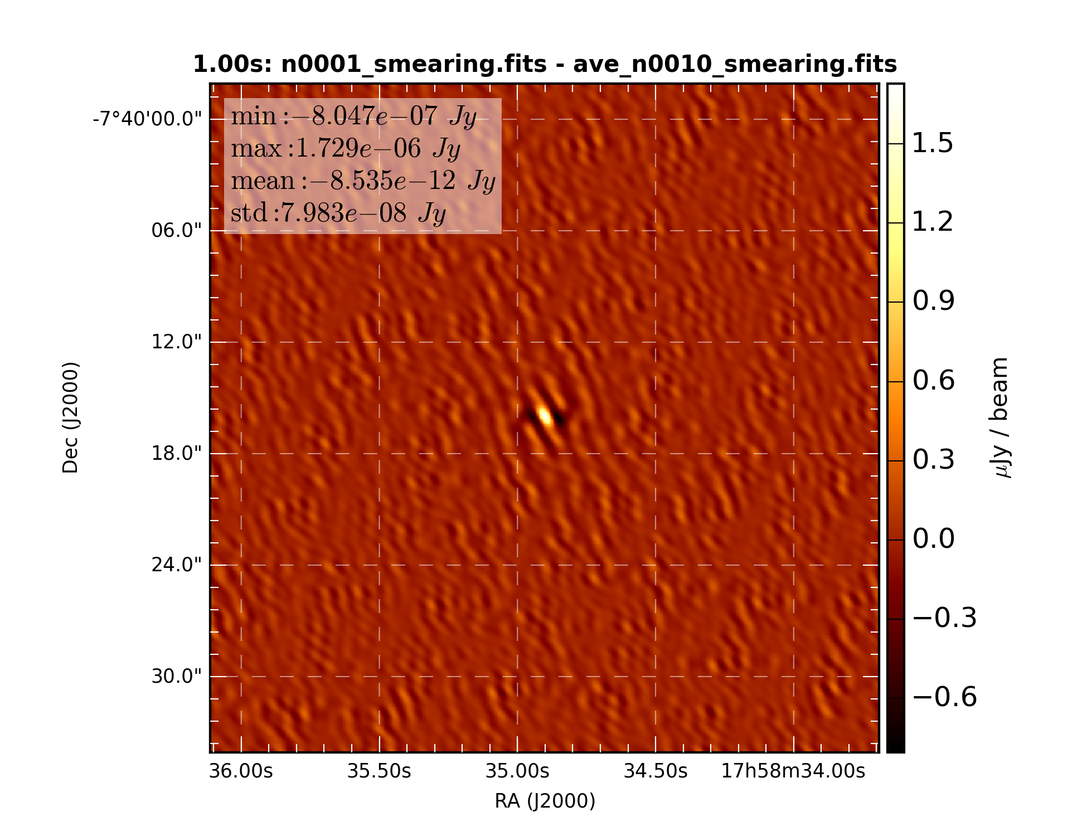

Figure 29: Difference of snapshot dirty image with average of 10 time smearing corrected sub-samples

### Average of 1000 snapshots

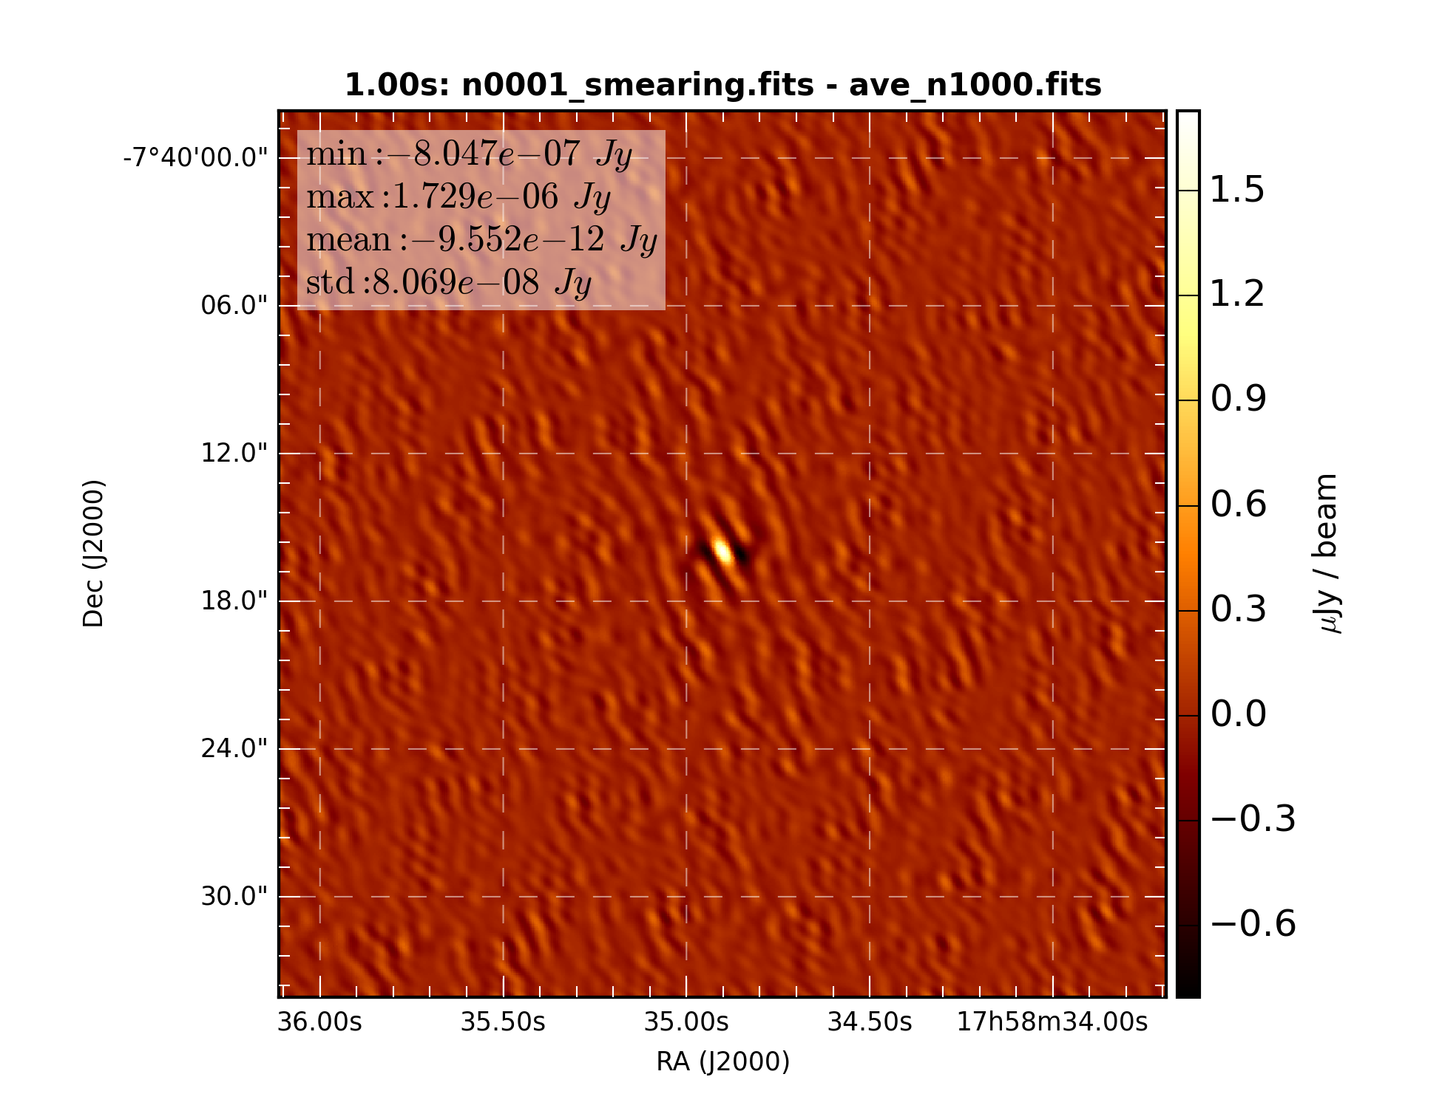

Figure 30: Difference of snapshot dirty image with average of 1000 sub-samples

## 

Figure 31: Difference of snapshot dirty image with average of 1000 time smearing corrected sub-samples

## Summary of results

|  |  |  |  |  |  |  |  |
| --- | --- | --- | --- | --- | --- | --- | --- |
| Dump time [s] | Corrected vs non-corrected 1 snapshot difference STD  [Jy/Beam] | Corrected 1 snapshot vs. 2 snapshot average difference STD [Jy/beam] | | Corrected 1 snapshot vs. 10 snapshot average difference STD [Jy/beam] | | Corrected 1 snapshot vs. 1000 snapshot average difference STD [Jy/beam] | |
| No correction | Correction | No correction | Correction | No correction | Correction |
| 0.05 | 3.669e-8 | 9.163e-9 | 1.316e-9 | 1.190e-9 | 1.213e-9 | 1.182e-9 | 1.182e-9 |
| 0.10 | 1.466e-7 | 3.612e-8 | 1.759e-9 | 1.818e-9 | 1.787e-9 | 1.729e-9 | 1.729e-9 |
| 0.50 | 3.662e-6 | 9.003e-7 | 1.520e-8 | 1.702e-8 | 2.006-e8 | 2.026e-8 | 2.026e-8 |
| 1.00 | 1.464e-5 | 3.598e-6 | 6.048e-8 | 6.727e-8 | 7.983e-8 | 8.069e-8 | 8.069e-8 |

Table 1: Summary of results.

## Conclusions

Time smearing correction works perfect for short intervals. This can be seen in the 0.05 s and 0.1 s results where the corrected and sum of 1000 sub-interval results are extremely close. For the longer interval, 0.5 s, this is no longer true with clear structure seen in the residual difference between the 0.5 s single snapshot with time smearing correction and the 1000 snapshot averaged results. As one might be more likely to believe the 1000 snapshot average over the analytical correction it would appear that for the ~157 km baselines of this telescope intervals longer than 0.1 should not be used.